Press Release

Stainless steel ultrasonic sensors for film extrusion

For demanding industrial applications - for example in film extrusion lines - sensor specialist PiL Sensors (www.pil.de) offers robust ultrasonic sensors with M18 stainless steel housings. Designed for detection ranges from 50mm to 1,600mm, the P47 series distance sensors are available with fixed or factory-adjustable characteristics. The entire P47 series features fast response times, temperature compensation and a synchronization function for up to ten sensors. This makes these ultrasonic sensors ideal for high-precision distance measurements, for example in film blowing machines for extrusion film production. Synchronization prevents mutual interference between the ultrasonic signals of several sensors. Electrostatic discharges, which can occur during film drawing, are absorbed by the metal housing so that the electronics of the sensor are not affected. The manufacturer supplies the device series, which is manufactured in protection class IP65 and approved for a temperature range of -20°C to +70°C, with M12 connection and either switching or analog output. In addition to various connection sockets and cables, reflector angles for sound detour as well as sound reducers and reducing rings are available as accessories.

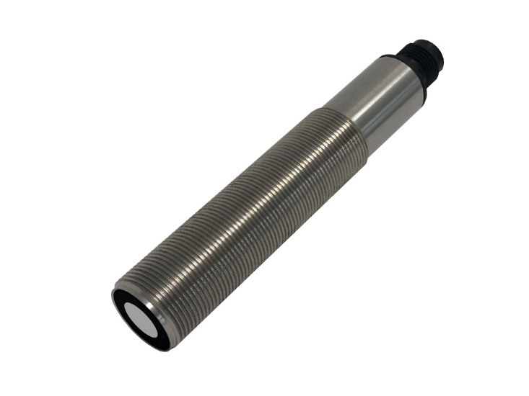
Caption: PiL ultrasonic sensors of the P47-50 series in stainless steel housings are ideally suited for high-precision distance measurement in film extrusion lines

Image/s: | P47-Edelstahlgehaeuse_2000px.jpg | Characters: | 1239
File name: | 202304063_pm_ p47_sensors_en.docx | Date: | 04-25-2023

About PIL
PiL Sensoren GmbH, with its headquarters in Erlensee near Frankfurt/Main is a pioneer of ultrasonic technology and has been developing, producing, and selling standard and customized sensor solutions for industrial applications since 1990. Together with Inelta Sensorsystem GmbH & Co. KG (Taufkirchen near Munich) and VYPRO s.r.o. (Trenčín, Slovakia), PiL offers a wide range of products for measuring displacement and position as well as force, pressure, and inclination. The range of products we offer includes force sensors, sensor signal amplifiers, pressure switches, capacitive sensors, and ultrasonic sensors. Our portfolio is nicely rounded off with cable and connector assembly services.
Most of the group of companies’ customers are in industrial automation, mechanical engineering, hydraulics, medical technology as well as the aerospace industry. We especially focus on industry and customer-specific sensor solutions and are constantly expanding this focus with interdisciplinary know-how.
Contact:  PIL Sensoren GmbH  Zweigstelle Süd  Reinhard Koch  Ludwig-Boelkow-Allee 22  82024 Taufkirchen  Germany  Phone: +49 89 / 452 245-0  Fax: +49 89 / 452 245-744  Email: marketing@pil.de  Internet: www.pil.de | gii die Presse-Agentur GmbH  Immanuelkirchstr. 12  10405 Berlin  Germany  Phone: +49 30 / 538 965-0  Email: info@gii.de  Internet: www.gii.de

