Press Release

Two-speed ship motor for positioning

Menzel Elektromotoren has manufactured a ship motor with two separate windings for different speeds. The motor was commissioned by a petroleum company and is to drive an azimuth thruster. The type MEBKSW630-8/10 three-phase squirrel-cage motor is certified by Lloyd's Register. The modular series, which features IP55 ingress protection and IC 81W cooling (air-to-water heat exchanger) by default, enables flexible, cost-efficient customization while at the same time offering a tested and proven design. The ship motor was constructed for a vertical mounting. The customer attached great importance to smooth commissioning through interchangeability with the previous motor. At a nominal voltage of 6000 V, the 8- and 10-pole rotor windings are designed for nominal outputs of 2000 kW and 800 kW and speeds of 895 rpm and 713 rpm respectively. The size 500 squirrel-cage motor weighs 12.5 tons. The motor series is also characterized by high power density, high efficiency, high overload capacity and high-durability bearing designs. Menzel also offers explosion-proof motor designs and motors with higher IP protection classes for marine and petrochemical applications.
More about special motors: https://www.menzel-motors.com/special-electric-motors/

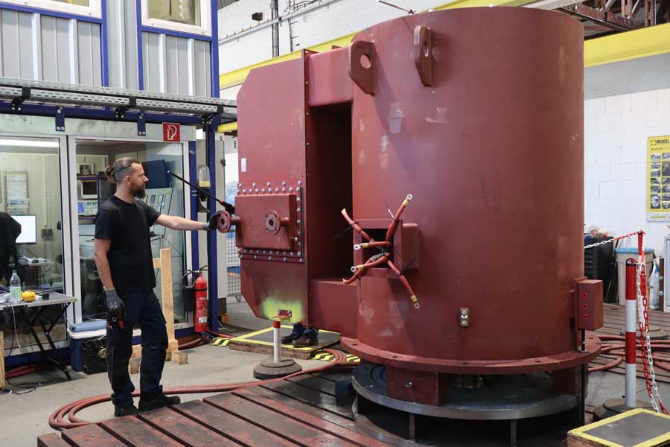
Caption: The special motor can drive a ship's azimuth thruster at two different speeds thanks to two separate windings

Image/s: | two-speed_ship_motor_mebksw630-8-10 | Characters: | 1171
File name: | 202305012_pm_two-speed_ship_motor_en | Date: | 05-03-2023
About Menzel Elektromotoren
Based in Berlin, Menzel Elektromotoren GmbH has been manufacturing and distributing electric motors since 1927. The medium-sized company specializes in the delivery of large electric motors, including special models, within the shortest possible time. The product range comprises high and low voltage motors, DC motors, transformers, and frequency inverters. Services include motor production and short-term adaptation of stocked motors to application-specific requirements. In order to ensure fast deliveries to the customer at all times, the company maintains a very extensive inventory including more than 20,000 motors with a maximum performance of up to 15,000 kW. Qualified engineering, experienced staff, and state-of-the-art production and testing facilities help Menzel provide excellent reliability. Menzel operates subsidiaries in the UK, France, Italy, Spain, and Sweden, and cooperates with numerous partners worldwide.
Menzel is currently building a new motor plant in Hennigsdorf, near Berlin. The future headquarters will go into operation in early 2024.
Contact:  Menzel Elektromotoren GmbH  Mathis Menzel  Neues Ufer 19 – 25  10553 Berlin  Germany  Phone: +49 . 30 . 349 922-0  Email: info@menzel-motors.com  Internet: www.menzel-motors.com |  | gii die Presse-Agentur GmbH  Immanuelkirchstr. 12  10405 Berlin  Germany  Phone: +49 . 30 . 538 9650  Email: info@gii.de  Internet: www.gii.de

