Press Release

MICON 5 SL: Tactile switches for high stresses

RAFI’s new MICON 5 SL series consists of extremely long-life versions of its practice-proven MICON 5 program. With an operating life of up to ten million actuation cycles, MICON 5 SL (Sealed & extended Lifetime) solutions are designed for joysticks and other control devices subject to high stress. High-quality gold contacts and housing dimensions of just 5.1 mm x 6.4 mm x 3.85 mm (LxWxH) ensure extremely reliable switching with minimal space requirement. MICON 5 SL key switches are available with SMT and for operating forces of 2.9 N and 5 N. Other salient features of the new Sealed & extended Lifetime versions are a temperature resistance of -40°C to +125°C and IP67 degree of protection, which makes them ideal for casting, painting, and nanocoating. An extensive accessory range offers compatible plungers, keycaps, and illumination solutions for every use case.

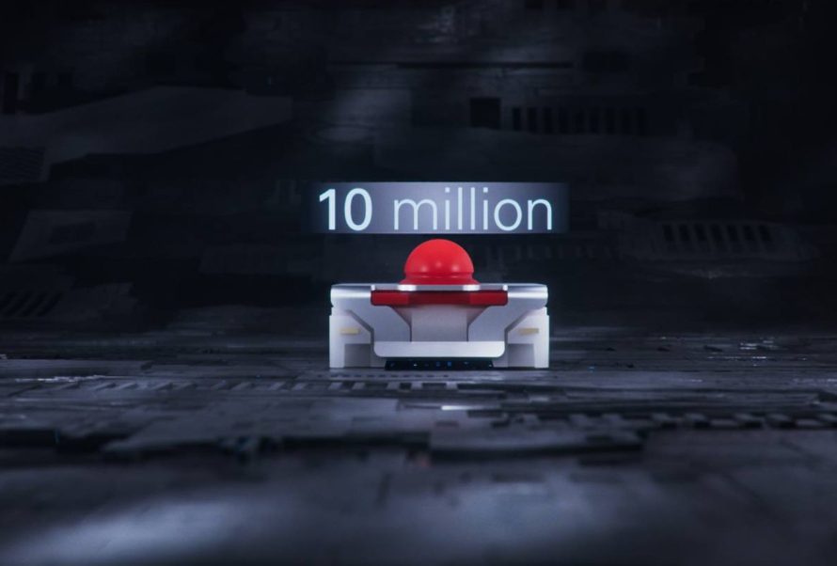
Caption: The new MICON 5 SL tactile switches have a lifetime of
up to ten million actuation cycles

Image/s: | micon5_sl_2000.jpg | Characters: | 876
File name: | 202306008_pm_MICON5_SL_en.docx | Date: | 07-25-2023

About the RAFI Group
Founded in 1900, RAFI today develops and produces electromechanical components and systems for human–machine interaction. The range of products includes key switches, switches, touchscreens, control systems and electronic assemblies. RAFI products are employed in many industries including automation, medical technology, machine and plant engineering, road and railway vehicles, household appliances and telecommunication. The RAFI Group operates internationally with more than 2,000 employees at sites in Germany, Europe, China, and the USA. Since 2020, it has been owned by the US investment company Oaktree. Its headquarters are in Berg, Germany.

Contact:
RAFI GmbH & Co. KG
Patrick Müller
Ravensburger Straße 128-134
88276 Berg
Phone: +49 751 89-1634
Email: patrick.mueller@rafi-group.com
Web: www.rafi-group.com

