Press Release

MICON 5 S: New generation of tactile switches from RAFI

RAFI is replacing its practice-proven MICON 5 tactile switches with a new series. The MICON 5 S range is even more robust. The outer dimensions remain the same, at just 5.1 mm x 6.4 mm and an installation height of 3.85 mm. However, an optimized sealing system upgrades the new key switch generation to IP67 degree of protection. This makes the tactile switches also suitable for use on PCBs protected after assembly by casting, painting, and nanocoating. Other qualities that distinguish the new series from the MICON 5 are a maximum operating temperature that is 35°C higher and a temperature resistance of -40°C to +125°C. This meets current automotive industry standards. Just like in the predecessor range, high-quality gold contacts ensure permanent switching reliability. MICON 5 S is available in both SMT and THT types and in versions with operating forces from 1.5 N to 7 N. Depending on the operating force, the lifetime is up to one million actuation cycles. RAFI ensures functional reliability with 100-percent testing of the force-travel characteristic curves. For installation of the key switches under overlays, the extensive accessory range offers round and square plungers in various dimensions and illumination variants, indicator fields for ring lighting, and bezels in all basic colors.

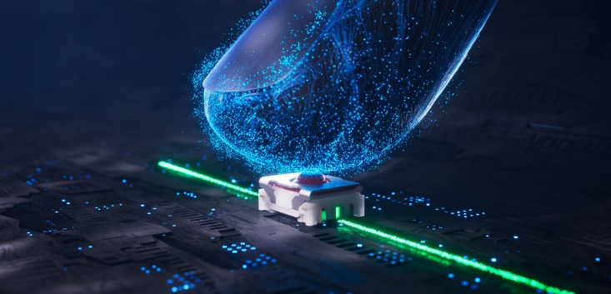
Caption: New-generation MICON 5 S micro-switch

Image/s: | micon5_taktilitaet_2000.jpg | Characters: | 1308
File name: | 202306010_pm_micon5-s_en.docx | Date: | 06-07-2023

About the RAFI Group
Founded in 1900, RAFI today develops and produces electromechanical components and systems for human–machine interaction. The range of products includes key switches, switches, touchscreens, control systems and electronic assemblies. RAFI products are employed in many industries including automation, medical technology, machine and plant engineering, road and railway vehicles, household appliances and telecommunication. The RAFI Group operates internationally with more than 2,000 employees at sites in Germany, Europe, China, and the USA. Since 2020, it has been owned by the US investment company Oaktree. Its headquarters are in Berg, Germany.

Contact:
RAFI GmbH & Co. KG
Tatjana Schweitzer
Ravensburger Str. 128–134
88276 Berg, Germany
Phone: +49 751 89-1468
Email: tatjana.schweitzer@rafi-group.com
Web: www.rafi-group.com

