Press Release

Mill motor with brush lifting

Menzel Elektromotoren has custom-built a mill motor with a short-circuiting and brush-lifting device. The motor with 710 mm shaft height and 2000 kW rated power operating at 4200 V will replace an older machine of different make for a ball mill in a cement plant. At the customer's request, Menzel replicated the features of the original machine, including a brush-lifting device, for which Menzel implemented a modern, reliable design. Few motor manufacturers have brush lifting in their portfolios currently. However, the family-run German company Menzel offers a full service for motors with brush lifting, from consultation to motor design and production, testing and commissioning, everything from a single source. The brush-lifting device reduces wear and tear on the motor brushes and is economically viable in applications with very long run times and very infrequent starts. After motor ramp-up, the rotor windings are short-circuited and the carbon brushes lifted. This eliminates the cost and effort required for regular brush replacement. In addition, since brush abrasion is reduced and significantly less carbon dust is released, the slip ring compartment, slip rings and filters can be cleaned much less frequently. The cement plant operator required a speedy and smooth changeover. The MEBSSL-type three-phase slip ring motor is configured to replace the existing motor one-to-one. It features protection class IP 55, insulation class H and cooling type IC 611 (air-to-air heat exchanger). Designing the machine and selecting the most suitable carbon brushes, Menzel also took into account the installation height at 2600 m AMSL.
More mill motor references: https://www.menzel-motors.com/mill-drive/

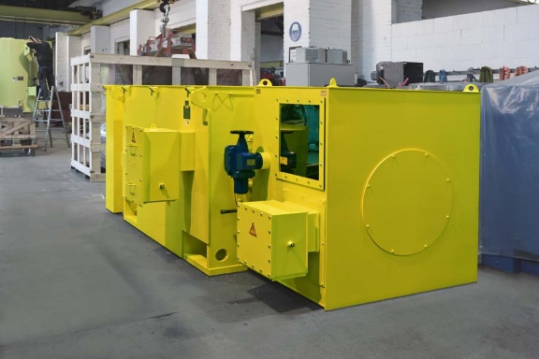
Caption: Menzel Elektromotoren has configured a slip ring motor with a short-circuiting and brush-lifting device for a cement mill

Image/s: | cement_mill_motor_w_brush_lifting | Characters: | 1645
File name: | 202306013_pm_brush_lifting_cement_mill_en | Date: | 06-20-2023
About Menzel Elektromotoren
Based in Berlin, Menzel Elektromotoren GmbH has been manufacturing and distributing electric motors since 1927. The medium-sized company specializes in the delivery of large electric motors, including special models, within the shortest possible time. The product range comprises high and low voltage motors, DC motors, transformers, and frequency inverters. Services include motor production and short-term adaptation of stocked motors to application-specific requirements. In order to ensure fast deliveries to the customer at all times, the company maintains a very extensive inventory including more than 20,000 motors with a maximum performance of up to 15,000 kW. Qualified engineering, experienced staff, and state-of-the-art production and testing facilities help Menzel provide excellent reliability. Menzel operates subsidiaries in the UK, France, Italy, Spain, and Sweden, and cooperates with numerous partners worldwide.
Menzel is currently building a new motor plant in Hennigsdorf, near Berlin. The future headquarters will go into operation in early 2024.
Contact:  Menzel Elektromotoren GmbH  Mathis Menzel  Neues Ufer 19 – 25  10553 Berlin  Germany  Phone: +49 . 30 . 349 922-0  Email: info@menzel-motors.com  Internet: www.menzel-motors.com |  | gii die Presse-Agentur GmbH  Immanuelkirchstr. 12  10405 Berlin  Germany  Phone: +49 . 30 . 538 9650  Email: info@gii.de  Internet: www.gii.de

