Press Release

XTREME-ECU - the latest control unit for RAFI control systems with x86 technology

With its GLASSCAPE range of touchscreens and control panels, the RAFI Group is a leading manufacturer of customer-specific touch control systems for industrial applications. The HMI specialist manufactures all the embedded control units (ECU) for its solutions in-house. This guarantees short development times and an optimal cost-benefit ratio at every stage. The program, which RAFI continually further develops, previously offered a choice of four ECU platforms in increasing performance classes from ECO-ECU (Cortex M0/M4), BALANCE-ECU (i.MX6SX), POWER-ECU (i.MX6Dual/Quad) to ULTIMATE-ECU (i.MX8Quad). Now the HMI specialist has completed the range with the high-performance XTREME-ECU, which uses the x86-based “Elkhart Lake” platform with a processor from Intel’s Atom-x6000E line. The chip architecture optimized for industrial applications comes with a wide range of advantages. They include low power consumption that enables fan-less operation, a wider temperature range of -40°C to +85°C, and support of standard operating systems such as Linux and Windows. As a result, XTREME-ECU significantly reduces the outlay for application-oriented software implementation compared to previous ARM-based ECU versions. What’s more, HTML5 applications also run smoothly on the system. XTREME-ECU is available as a SMARC plug-in module. This means that for the first time device manufacturers can offer their products as x86 systems for industrial applications with fan-less design and long-term availability.

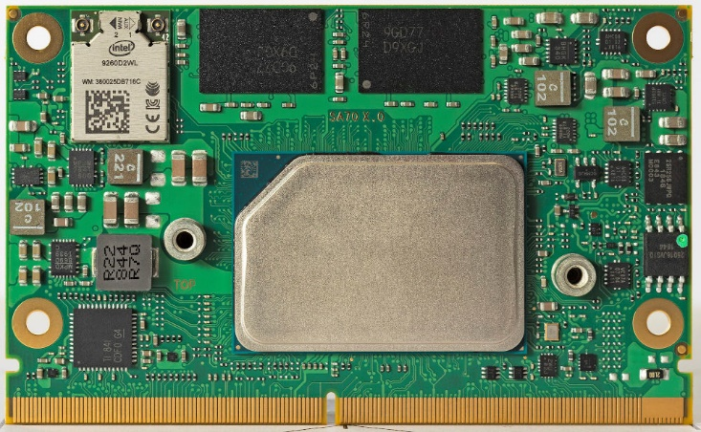
Caption: High-performance ECU with Atom x6000E processor and optimized chip architecture for fanless operation

Image/s: | ecu-xtreme_86_plain_2000px.jpg | Characters: | 1,509
File name: | 202306015_pm_ecu-xtreme_en.docx | Date: | 06-28-2023
About the RAFI group
Founded in 1900, RAFI today develops and produces electromechanical components and systems for human–machine interaction. The range of products includes pushbuttons, switches, touchscreens, control systems and electronic assemblies. RAFI products are employed in many industries including automation, medical technology, machine and plant engineering, road and railway vehicles, household appliances and telecommunication. The RAFI group operates internationally with more than 2,000 employees at sites in Germany, Europe, China and the USA. Its headquarters are in Berg, Germany.
Contact:
RAFI GmbH & Co. KG
Tatjana Schweitzer
Ravensburger Str. 128–134
88276 Berg, Germany
Phone: +49 751 89-1468
Email: tatjana.schweitzer@rafi-group.com
Web: www.rafi-group.com

