Press Release

Vision Components at LASER World of PHOTONICS:
MIPI cameras and smart embedded vision systems

At LASER World of PHOTONICS, Vision Components (booth A3-123) will present new MIPI camera modules and embedded vision systems for time-saving, cost-effective development of customized solutions. Highlights include embedded cameras with a MIPI CSI-2 interface, featuring IMX565, IMX566, IMX567 and IMX568 global shutter sensors from the Sony Pregius S series. The camera modules developed and manufactured by Vision Components in Germany combine high image quality and light sensitivity with fast image capture – the perfect fit for a wide range of industrial and commercial applications.

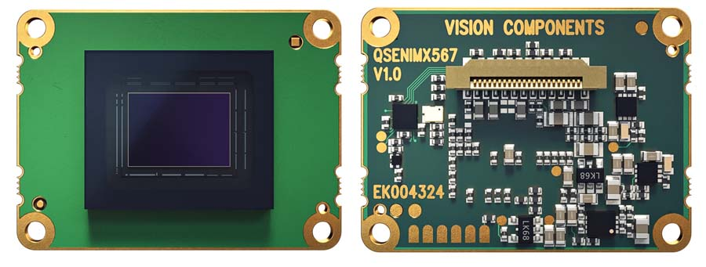
Caption: Vision Components presents new MIPI cameras with high-performance image sensors for embedded vision designs at LASER Munich

Up to 12 megapixels and global shutters
The VC MIPI IMX565 MIPI camera module with a 12-megapixel sensor offers a maximum resolution of 4096 x 3000 pixels and a frame rate of 42 fps. Also new, the VC MIPI IMX566 is an 8-megapixel camera module with 62 fps, and the VC MIPI IMX567 and VC MIPI IMX568 modules boast 5-megapixel sensors and 96 fps. All VC MIPI camera modules are available in monochrome and color variants.

Designed for industrial series development – even with individually specified sensors
VC MIPI modules feature high quality, a ruggedized design and guaranteed long-term availability. The MIPI CSI-2 port allows for easy connection to all common processor platforms. Vision Components provides the corresponding drivers free of charge. The market leader is continuously adding more image sensors to the VC MIPI portfolio, also including applications such as SWIR and 3D/ToF. On request, Vision Components also integrates special sensors into MIPI modules, even image sensors with no native MIPI interface.

Smart components: from an FPGA accelerator to modular laser profilers
At LASER World of PHOTONICS, Vision Components will also showcase smart components for faster, easier and more cost-efficient OEM embedded vision development. These include the VC Power SoM FPGA accelerator for complex image processing and easy design-in, modular VC nano 3D-Z laser profilers, and the VC picoSmart 3D miniature board camera for the development of ultra-compact and cost-effective OEM 3D triangulation sensors.

Vision Components at LASER World of PHOTONICS
Munich, Germany, 27 – 30 June 2023
Hall A3, Stand 123

Image/s: | vc_mipi_imx567_camera_module_bf | Characters: | 2103
File name: | 202306017_pm_laser_munich_en | Date: | 06-13-2023
About Vision Components
Vision Components is a leading international manufacturer of embedded vision systems. The freely programmable cameras with powerful onboard CPUs perform image processing tasks on their own without the need for an additional computer. Vision Components offers OEMs versatile Linux-based embedded systems for 2D and 3D image processing, supplied as board cameras or in protective casings. These are complemented by a growing range of ultracompact MIPI camera boards, which connect to a variety of different CPU boards. In addition, Vision Components offers software libraries and develops customized solutions on request. The team of experts can draw on extensive knowledge and over 20 years of experience with imaging applications. The company based in Ettlingen in southwestern Germany was founded in 1996 by Michael Engel, the inventor of the first industrial-grade intelligent camera. More world premieres followed, including the world's first intelligent vision sensors and the first-ever embedded 3D laser profiler. Today, Vision Components has sales offices in the United States and Japan and works with local partners in over 25 countries to provide consistent customer focus and readily available expertise throughout the world.
Contact:  Vision Components GmbH  Jan-Erik Schmitt  Ottostr. 2  76275 Ettlingen  Germany  Phone: +49 . 7243 . 21670  Email: schmitt@vision-components.com  Internet: www.vision-components.com |  | gii die Presse-Agentur GmbH  Immanuelkirchstr. 12  10405 Berlin  Germany  Phone: +49 . 30 . 538 9650  Email: info@gii.de  Internet: www.gii.de

