Press Release

RAFI presents new Polish distribution partner

To drive its further expansion in the Eastern European economic area, HMI expert RAFI signed a contract with DACPOL in April 2023, making it the company’s new distribution partner for the Polish market. Founded in 1992 in Piaseczno near Warsaw, the company specializes in selling electrical components for power electronics, process automation, and electrical and energy technology. DACPOL supplies customers in a wide range of industries with quality products from numerous leading producers. Its customers include manufacturers of drive units, welding machines, power supply devices, electrical equipment for traffic systems, vehicles, and consumer electronics – but also research institutes, service centers, and commercial companies. By adding RAFI products to its sales range, the distributor is expanding its portfolio and increasing the availability of high-end control components, actuators, and switching elements in the Polish region. The two companies made their first joint appearance in April at the Warsaw Pack international trade show for packaging technology and materials. Visitors were particularly interested in the RAFI actuators displayed for the first time on a new sample panel on the DACPOL stand.

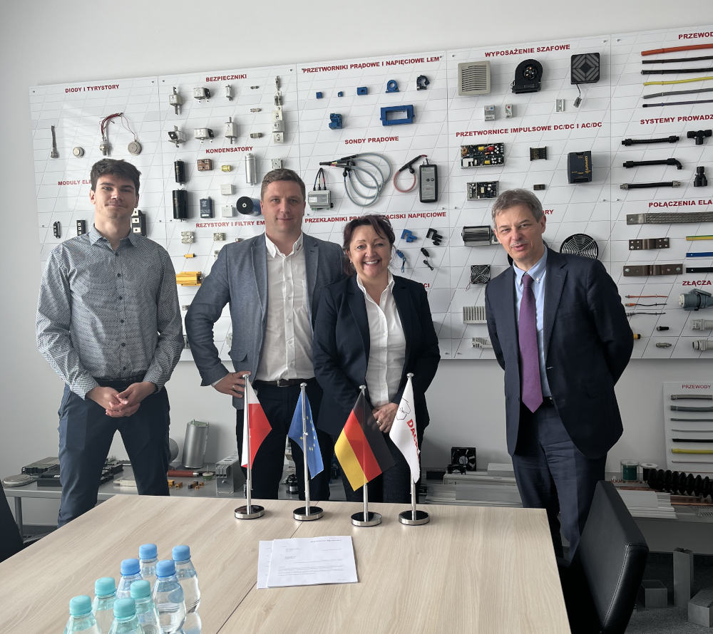
Caption 1: Delighted with the new partnership (left to right): Kacper Gugala (Sales Engineer, DACPOL), Marek Piatkowski-Zajec (Head of Sales, DACPOL), Barbara Wörz (Distribution Manager, RAFI), Maciej Sitnik (CEO, DACPOL)

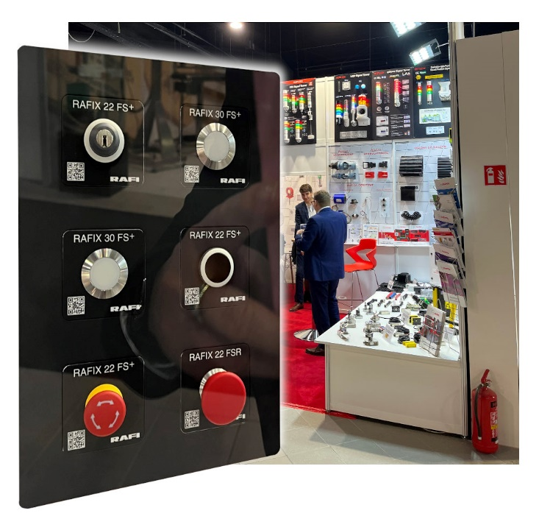
Caption 2: On the DACPOL stand at the Warsaw Pack, RAFI unveiled its brand-new demo rack populated with sample panels

Image/s: | contract_dacpol_2000px.jpg  rafi-panel-dacpol-messe2_2000px.jpg | Characters: | 1,221
File name: | 202306019_pm_dacpol_en.docx | Date: | 06-14-2023

About the RAFI Group
Founded in 1900, RAFI today develops and produces electromechanical components and systems for human–machine interaction. The range of products includes key switches, switches, touchscreens, control systems and electronic assemblies. RAFI products are employed in many industries including automation, medical technology, machine and plant engineering, road and railway vehicles, household appliances and telecommunication. The RAFI Group operates internationally with more than 2,000 employees at sites in Germany, Europe, China, and the USA. Since 2020, it has been owned by the US investment company Oaktree. Its headquarters are in Berg, Germany.

Contact:
RAFI GmbH & Co. KG
Tatjana Schweitzer
Ravensburger Str. 128–134
88276 Berg, Germany
Phone: +49 751 89-1468
Email: tatjana.schweitzer@rafi-group.com
Web: www.rafi-group.com

