Press Release

Gossen Metrawatt incorporates Kurth Electronic

As of July 2023, Kurth Electronic GmbH, which has been part of the GMC-Instruments Group since 2016, will be incorporated into Gossen Metrawatt GmbH while the Kurth Electronic brand will continue. Gossen, a leading manufacturer of test and measurement technology for electrical safety, thus expands its portfolio in telecommunications and data technology. “We are confident that the integration will combine the strengths of both companies and enhance our capability to offer our customers state-of-the-art, innovative measurement and testing technology for their requirements today and in future,” says Marcel Hutka, Managing Director at Gossen Metrawatt. In addition to the Gossen Metrawatt and Kurth Electronic brands, the Group's portfolio also comprises Camille Bauer measurement solutions for network analysis and power quality and the Rigel Medical brand with measuring and test equipment for medical technology.

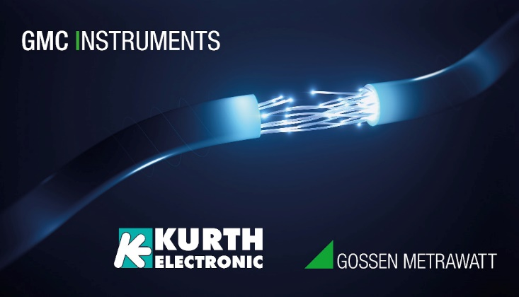
Caption: Gossen Metrawatt takes over Kurth Electronic GmbH and the promotion of the established Kurth brand as of July 2023

Image/s: | kurth_gome-gmci | Characters: | 919
File name: | 202306026_pm_kurth_electronic_en | Date: | 06-28-2023
About Gossen Metrawatt
Gossen Metrawatt, one of the world’s leading suppliers of measurement systems, develops and distributes a wide range of high-quality measuring and test devices for electrical trade, various industries and the public sector.
The Gossen Metrawatt brand has been synonymous with safety and quality “Made in Germany” for decades. Its product range includes measurement and test technology for the electrical safety of plants, devices and machines as well as for the e-mobility and medical technology industries. Additional key areas of interest are power quality, battery testing technology, multimeters, calibrators, power supply technology and energy management systems. For a truly comprehensive electrical safety portfolio, Gossen Metrawatt also offers a continuously growing range of digital services and cloud services and supports its customers with a versatile training program and a wide range of after-sales services.
Gossen Metrawatt is part of the GMC Instruments Group, which also includes other specialized manufacturers for measurement and testing technology – notably, Camille Bauer Metrawatt, Dranetz, Prosys, Seaward and Rigel and Kurth Electronic. The Camille Bauer and Rigel brands add to the portfolio various transducers, display instruments and detection systems for heavy-current engineering as well as special measuring, testing and functional testing devices for the medical sector. The GMC-I Group runs its own DAkkS-certified calibration center that performs DAkkS, ISO and factory calibrations for virtually all electrical measured quantities. The GMC-I Group has development and production sites in Germany, Switzerland, England and the USA and a worldwide sales network of its own companies as well as sales partners.
Contact:  Gossen Metrawatt GmbH  Christian Widder  Head of Marketing Communication  Suedwestpark 15  90449 Nuremberg  Germany  Phone: +49 . 911 . 8602-572  Email: christian.widder@gossenmetrawatt.com  Internet: www.gossenmetrawatt.com |  | gii die Presse-Agentur GmbH  Immanuelkirchstr. 12  10405 Berlin  Germany  Tel.: +49 . 30 . 538 9650  Email: info@gii.de  Internet: www.gii.de

