Press Release

HMI specialist RAFI acquires Xymox Technologies Inc.
Xymox enhances design, engineering and production capabilities;
RAFI dramatically expands presence within North America

Berg / Ravensburg, Germany and Milwaukee, WI, USA, July 14, 2023 - To strengthen its market presence in the USA and accelerate its global growth strategy, RAFI Group, one of the leading suppliers of electromechanical components, electronic assemblies, and systems for human-machine communication, acquired the U.S. company, Xymox Technologies, based in Milwaukee, WI.
Xymox Technologies, Inc. has over 40 years of experience developing and manufacturing capacitive sensors and membrane switches of the highest quality, with a broad customer portfolio that is compatible with RAFI, and a nationwide sales force. "Combining RAFI's product and technology know-how with Xymox Technologies' competencies and structures, results in a powerful entity in the American market that will further drive our growth strategy." comments Dr. Lothar Seybold, CEO of the RAFI Group on the acquisition.
RAFI recorded strong growth in the development and manufacture of complex customer-specific operating systems for human-machine communication in recent years and aims to further expand its position as an innovation leader in this sector globally. In this context, the markets in Asia and North America are the main strategic focus.
Bob Hartline, CEO of Xymox Technologies, added, “Innovation. Integrity. Service. Results. This is the Xymox culture, and this is the RAFI culture. This merger will help us better serve our customers with the latest HMI technology and global manufacturing capabilities while providing an environment for our employees to grow. It is a perfect match.”
"With Xymox, we have succeeded in acquiring a company that is an ideal fit for the RAFI family." Lothar Arnold, CFO of the RAFI Group, elaborates. "Xymox has built an excellent reputation in the U.S. in the field of human-machine communication, as a company with great technological expertise, reliable products and a deep understanding of its customers' needs."
The parties have agreed not to disclose the financial terms of the transaction.

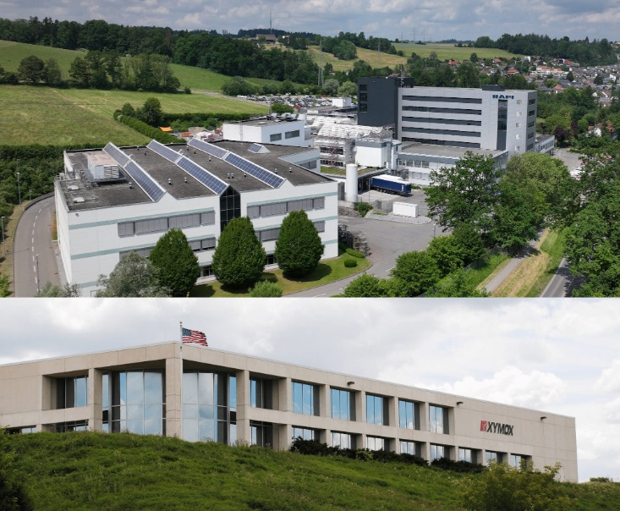
Caption: The RAFI Group acquires the U.S. company Xymox Technologies Inc. based in Milwaukee

Image/s: | rafi-berg_xymox_2000px.jpg | Characters: | 1,937
File name: | 202307005_pm_rafi_xymox_en.docx | Date: | 07-12-2023
About the RAFI Group
Founded in 1900, the company develops and produces electromechanical components and systems for man-machine communication. These include buttons, switches, touch screens and operating systems as well as electronic assemblies. RAFI products are used in medical technology, mechanical and plant engineering, road and rail vehicles, household appliances and telecommunications, among other applications. The RAFI Group operates worldwide with around 2,500 employees at locations in Germany, Hungary, Italy, Poland, China and the USA. The headquarters of the RAFI Group is located in Berg near Ravensburg, Germany.

About Xymox
Xymox was established in 1979 Milwaukee, Wisconsin as a manufacturer of membrane switches and operates a 58,000 square foot facility. Xymox Technologies’ 85 employees specialize in the screen printing of conductive inks on to flexible substrates, die cutting, laminating and assembly to produce high quality human machine input devices for the medical device and industrial control market spaces.

Contact:
Dr. Lothar Seybold
CEO
RAFI GmbH & Co. KG
E-mail: lothar.seybold@rafi-group.com
Phone: 0751 / 89-6460

Bob Hartline
CEO
Xymox Technologies
E-mail: bhartline@xymox.com
Phone: 414.362.9000

