Press Release

Brush lifting devices added to standard portfolio

Menzel Elektromotoren can fit slip ring motors with short-circuiting and brush-lifting devices on request and has now added this option to its standard portfolio. Motor brush lifting can be worthwhile for motors from about size 630 operating with long running times and infrequent restarts. It serves to significantly reduce maintenance requirements. Sample applications include pumps, fans and conveyors in continuous operation (duty type S1). After motor ramp-up, the rotor windings can be short-circuited and the carbon brushes lifted. This reduces brush wear. Smaller brushes can be used, which often last the entire motor lifespan. This eliminates the cost and effort required for regular brush replacement. Also, the slip ring compartment needs to be cleaned much less frequently due to reduced amounts of carbon dust. The modular brush-lifting devices feature a top-quality, low-maintenance and extremely robust design. Specifically designed for each application, the slip-ring body, including the short-circuit ring, is dimensioned relative to the motor rotor data. The carbon brushes are selected to suit the application and the place of use. The travel range of the brush rocker is adjusted, allowing the rollers to rest during normal operation and thus saving wear. Customers looking to source a slip ring motor with a short-circuiting and brush-lifting device benefit from the fact that Menzel is a one-stop shop for motors featuring this facility, offering selection, configuration, manufacture, testing and commissioning.
More: https://www.menzel-motors.com/brush-lifting-device/

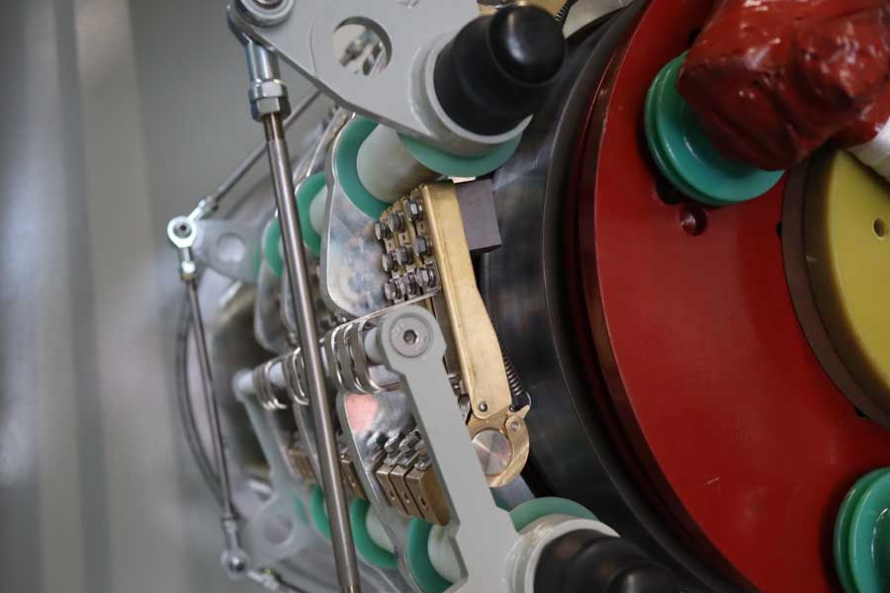
Caption: Menzel designs and manufactures slip ring motors with short-circuiting and brush-lifting devices in a tried-and-tested design from a single source

Image/s: | carbon_brushes_screwed_onto_brush_rocker | Characters: | 1535
File name: | 202307006_pm_brush_lifting_en | Date: | 08-16-2023
About Menzel Elektromotoren
Based in Berlin, Menzel Elektromotoren GmbH has been manufacturing and distributing electric motors since 1927. The medium-sized company specializes in the delivery of large electric motors, including special models, within the shortest possible time. The product range comprises high and low voltage motors, DC motors, transformers, and frequency inverters. Services include motor production and short-term adaptation of stocked motors to application-specific requirements. In order to ensure fast deliveries to the customer at all times, the company maintains a very extensive inventory including more than 20,000 motors with a maximum performance of up to 15,000 kW. Qualified engineering, experienced staff, and state-of-the-art production and testing facilities help Menzel provide excellent reliability. Menzel operates subsidiaries in the UK, France, Italy, Spain, and Sweden, and cooperates with numerous partners worldwide.
Menzel is currently building a new motor plant in Hennigsdorf, near Berlin. The future headquarters will go into operation in early 2024.
Contact:  Menzel Elektromotoren GmbH  Mathis Menzel  Neues Ufer 19 – 25  10553 Berlin  Germany  Phone: +49 30 349 922-0  Email: info@menzel-motors.com  Internet: www.menzel-motors.com |  | gii die Presse-Agentur GmbH  Immanuelkirchstr. 12  10405 Berlin  Germany  Phone: +49 30 538 965-0  Email: info@gii.de  Internet: www.gii.de

