Press Release

Six days instead of six months delivery

Motor customers in the UK are currently particularly pleased with the fast delivery capability of German manufacturer Menzel Elektromotoren. In early June, the family-run company received two orders for large machines within one week. Due to motor failures, the water supply to 30,000 households was threatened and production in a cement plant was halted. After delivery times of only six and ten days, respectively, both the pump and the cement mill could be restarted in the shortest imaginable time. Faced with unexpected downtime due to equipment failures, customers often cannot afford to wait for a motor manufactured from scratch – standard delivery times in higher output ranges start at six months. Menzel has proven itself to be a strong partner in an emergency, quickly configuring suitable motor systems for a wide range of high-output applications from its large, diverse stock of motors, cooling units and ancillary equipment – such as the current two jobs for British customers. The squirrel cage pump motor has a nominal output of 1380 kW operating at 3300 V. The slip-ring motor for a cement mill delivers 2000 kW at 11 kV. Its special features are increased ingress protection rated IP55 and a closed cooling system with a top-mounted air-to-air heat exchanger (cooling type IC 611), ideal for dusty environments and large temperature fluctuations.
Large industrial motors from stock and quickly tailored to order: https://www.menzel-motors.com/article/large-lv-mv-hv-motors/

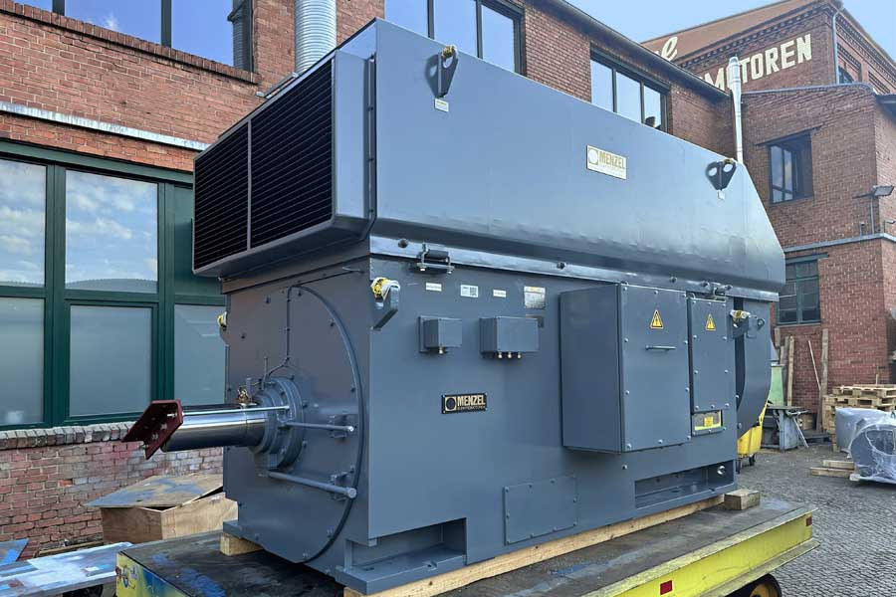
Caption: Menzel's large warehouse and modular design for motors and coolers allow fast delivery of tailored motor systems for industrial applications (here: 2000kW 11kV cement mill motor)

Image/s: | cement_mill_motor_mebssl630-06-196 | Characters: | 1366
File name: | 202307013_pm_fast_delivery_to_uk_en | Date: | 07-04-2023
About Menzel Elektromotoren
Based in Berlin, Menzel Elektromotoren GmbH has been manufacturing and distributing electric motors since 1927. The medium-sized company specializes in the delivery of large electric motors, including special models, within the shortest possible time. The product range comprises high and low voltage motors, DC motors, transformers, and frequency inverters. Services include motor production and short-term adaptation of stocked motors to application-specific requirements. In order to ensure fast deliveries to the customer at all times, the company maintains a very extensive inventory including more than 20,000 motors with a maximum performance of up to 15,000 kW. Qualified engineering, experienced staff, and state-of-the-art production and testing facilities help Menzel provide excellent reliability. Menzel operates subsidiaries in the UK, France, Italy, Spain, and Sweden, and cooperates with numerous partners worldwide.
Menzel is currently building a new motor plant in Hennigsdorf, near Berlin. The future headquarters will go into operation in early 2024.
Contact:  Menzel Elektromotoren GmbH  Mathis Menzel  Neues Ufer 19 – 25  10553 Berlin  Germany  Phone: +49 . 30 . 349 922-0  Email: info@menzel-motors.com  Internet: www.menzel-motors.com |  | gii die Presse-Agentur GmbH  Immanuelkirchstr. 12  10405 Berlin  Germany  Phone: +49 . 30 . 538 9650  Email: info@gii.de  Internet: www.gii.de

