Press Release

LOXrail trolleys with telescopic axis

LOSYCO, a specialist in rail-based intra-logistics and feeding systems, has laid five floor-level LOXrail tracks for a German machine manufacturer's two assembly lines. A newly developed transport solution allows the transport system to be adapted to three different track widths: a telescopic axis connects two customized carriers with a 1.5-ton payload, each featuring two double-roller wheelsets. This enables variable transport setups for machines with different dimensions. Loads are directly positioned on the carriers, which feature a rubberized contact surface. For example, machines can be placed on a two-axes combination and manually pushed from one assembly station to the next. Larger machines can be transported using all three tracks and four carrier combinations alternately positioned on different tracks. The carriers can be designed for payloads up to 5 tons for even more enhanced flexibility and scalability of the LOXrail system, which has already proven itself worldwide in various applications for optimized production logistics, material flow and machine feeding across all industries. The floor-level rail system ensures barrier-free access on the shop floor for staff, mobile racks and pallet jacks.

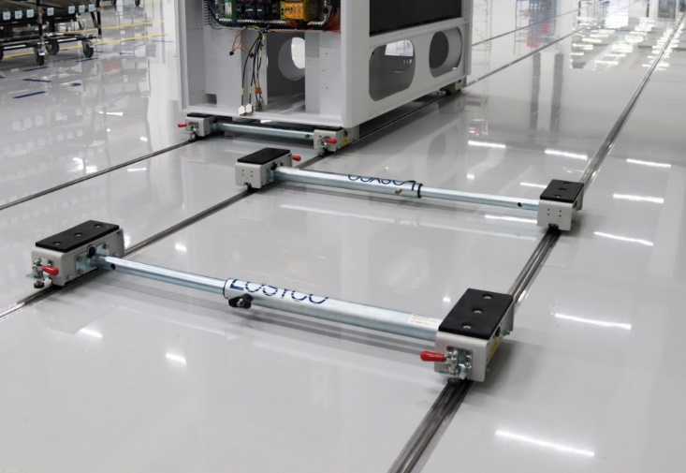
Caption: LOSYCO has tailored trolleys with telescopic axes for intra-logistics transport on LOXrail tracks with different widths

Image/s: | radsatz-teleskopachse_2000px.jpg | Characters: | 1226
File name: | 202307022_pm_telescopic_axis_en.docx | Date: | 07-12-2023
About Losyco
LOSYCO designs, builds, and installs intra-logistics systems for the manufacturing industry. The company based in Bielefeld, Germany, was founded by experienced engineers in 2016. LOSYCO’s core product is the LOXrail® floor rail system for easy transport and precise positioning of loads weighing several tons. LOXrail transport platforms can be operated manually or with auxiliary drives. LOSYCO also supplies handling equipment such as chain and roller conveyors, material management and storage systems, as well as sound-proof cabins and machine covers. LOSYCO supports customers wishing to transform their production processes to lean manufacturing and continuous flow production. LOSYCO is a member of the DRECKSHAGE Family.
Contact:  LOSYCO GmbH  Member of the DRECKSHAGE Family  Manuel Granz  Walter-Werning-Str. 7  33699 Bielefeld  Germany  Tel.: +49 . 521 . 945 643-0  Email: info@losyco.com  Internet: www.losyco.com |  | gii die Presse-Agentur GmbH  Immanuelkirchstr. 12  10405 Berlin  Germany  Tel.: +49 . 30 . 538 965-0  Email: info@gii.de  Internet: www.gii.de

