Press Release

Stingray IP66 protective enclosures for line-scan cameras and other large camera formats

New lightweight Stingray enclosures launched by autoVimation provide reliable protection for cameras with cross sections up to 75 mm x 75 mm. The enclosure profile is roomy enough for line-scan cameras as well as other large camera models that are too large for Orca-type enclosures, such as Allied Vision Bonito Pro or Flir A6xx thermal imaging cameras. The manufacturer offers BK7 or acrylic glasses up to ~2000 nm and sapphire and germanium discs for sensors in the infrared wavelength range. Stingray enclosures come in three standard lengths and with different window options. The “flange” version can be used with a Meganova ring light, all Orca front lids, including the dome window, and 30-mm and 60-mm extensions for easy lens access. Thanks to the flexible Quick-Lock/Heat-Guide camera mount, lenses can be positioned directly behind the enclosure window to avoid vignetting. In addition, special front covers are available for time-of-flight (ToF) cameras from IFM and Lucid and others. In addition to a high IP66 protection rating, the anodized aluminum enclosures feature high chemical resistance, vibration-proof mounting and very good heat dissipation, which ensures passive cooling of the installed camera. Both a 40-mm dovetail and a T-slot can be used for mounting. The manufacturer offers a wide range of accessories that facilitate efficient and reliable configurations for all kinds of demanding application scenarios; these include various mounting kits, sunroofs, protective lids, air nozzles, heating plates and cooling technology.
More information: https://www.autovimation.com/en/enclosures-en/stingray

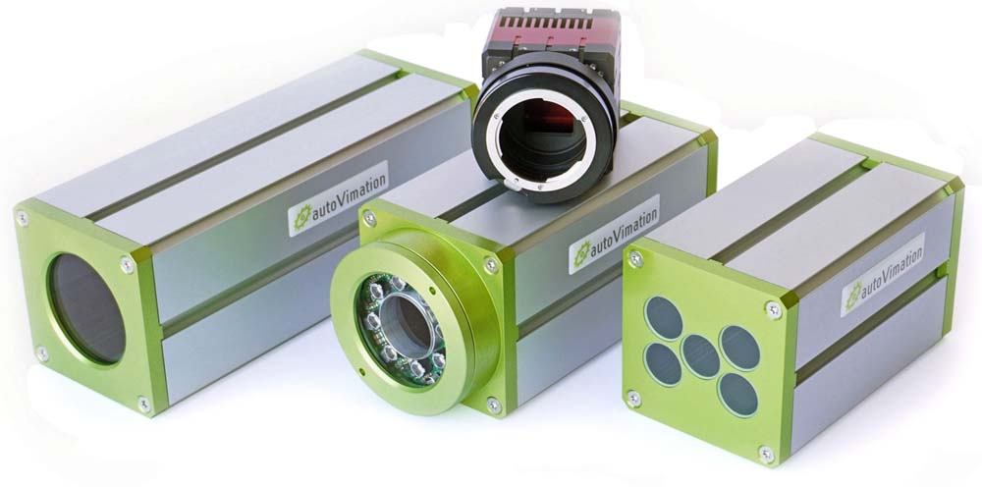
Caption: The new protective Stingray enclosures fit up to 75 mm x 75 mm wide cameras

Image/s: | stingray_camera_enclosure_group | Characters: | 1555
File name: | 202307025_pm_stingray_camera_enclosures_en | Date: | 07-19-2023
About autoVimation
The German manufacturer autoVimation was founded in 2008 by Peter Neuhaus to provide solutions for easier installation and adjustment of image processing components. The company has developed a modular construction kit that simplifies the connection of all required components, which does away with costly and time-consuming manufacturing of dedicated mounting brackets. The product portfolio also includes compact, easy-to-integrate enclosures that provide optimal protection for cameras and lenses in industrial applications, and ensure good heat dissipation. autoVimation supplies complete, ready-to-install mechanical solutions for cameras and light fittings, and enables the integration of special lenses, filters, light barriers, encoders, or other sensors.
autoVimation's customers include renowned companies from various industry branches, such as the pharmaceutical and food industry, measuring technology, quality control, and security technology.
Contact:  autoVimation GmbH  Peter Neuhaus  Roemerweg 1  76287 Rheinstetten  Germany  Phone: +49 . 721 . 627 6756  Email: sales@autovimation.com  Internet: www.autovimation.com |  | gii die Presse-Agentur GmbH  Immanuelkirchstr. 12  10405 Berlin  Germany  Phone: +49 . 30 . 538 9650  Email: info@gii.de  Internet: www.gii.de

