Press Release

PiL express service: Ultrasonic sensor production within 48h

PiL, a specialist in industrial ultrasonic sensor technology, has introduced an express service for rapid quotation and production of up to ten units per item according to existing customer specifications. With the new service offer, the manufacturer can supply its customers with special solutions of its ultrasonic sensor technology very promptly in case of replacement requirements or for test purposes. Customer inquiries can be submitted directly on the PiL corporate website using the contact form and will be answered within one working day with a binding offer. Express production and delivery take place within 48 hours. A contact person is available by telephone to provide additional advice. The express service is available at the following web address: https://www.pil.de/en/service/24h-quote

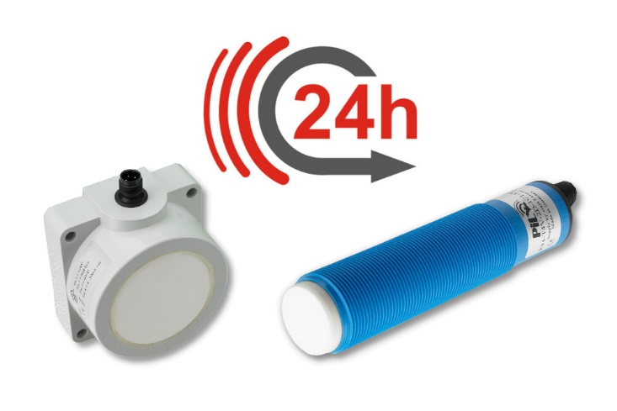
Caption: PiL express service: quotes for ultrasonic sensors according to existing customer specifications within one working day, and small-series production of up to 10 sensors in two working days

Image/s: | pil_24h-service | Characters: | 805
File name: | 202307028_pm_express_service_en | Date: | 07-19-2023
About PIL
PiL Sensoren GmbH, with its headquarters in Erlensee near Frankfurt/Main, Germany, is a pioneer of ultrasonic technology and has been developing, producing, and selling standard and customized sensor solutions for industrial applications since 1990. Together with Inelta Sensorsystem GmbH & Co. KG (Taufkirchen near Munich) and VYPRO s.r.o. (Trenčín, Slovakia), PiL offers a wide range of products for measuring displacement and position as well as force, pressure, and inclination. The product range includes force sensors, sensor signal amplifiers, pressure switches, capacitive sensors, and ultrasonic sensors. The portfolio is rounded off with cable and connector assembly services.
Most of the group of companies’ customers are in industrial automation, mechanical engineering, hydraulics, medical technology as well as the aerospace industry. The manufacturers especially focus on industry and customer-specific sensor solutions and are constantly expanding this focus with interdisciplinary know-how.
Contact:  PIL Sensoren GmbH  Zweigstelle Sued  Reinhard Koch  Ludwig-Boelkow-Allee 22  82024 Taufkirchen  Germany  Phone: +49 89 452 245-0  Fax: +49 89 452 245-744  Email: marketing@pil.de  Internet: www.pil.de |  | gii die Presse-Agentur GmbH  Immanuelkirchstr. 12  10405 Berlin  Germany  Phone: +49 30 538 965-0  Email: info@gii.de  Internet: www.gii.de

