Press Release

Pump motor with brush-lifting device

Menzel Elektromotoren is a one-stop shop for high-output electric motors, on request also offering various complementary services. A recently completed pump motor with all accessories as well as installation and commissioning is a finalist for 'Project of the Year' in the 2023 AEMT Awards of the Association of Electrical and Mechanical Trades. This project also stands out as the motor has been equipped with a short-circuiting and brush-lifting device. The three-phase slip-ring induction motor drives the peak load pump for Baden-Württemberg state water supply, a German special-purpose association. Due to the brush-lifting device, the motor carbon brushes are only used during motor startup and then lifted off the slip rings. This minimizes wear and tear and allows significantly longer maintenance intervals because the brushes no longer need to be replaced regularly and the slip ring compartment rarely needs to be cleaned of carbon dust. In addition to a slip-ring motor with brush lifting, the scope of supply also included a motor base frame, coupling, liquid starter and cabling to the nearest switchgear. The size 800 motor with a nominal output of 6200 kW at 5000 V nominal voltage drives the peak load pump in the summer months and is becoming increasingly important due to climate change and higher daily water requirements. Menzel fully tested the motor in the presence of the customer and then installed it and put it into operation at the waterworks. By replacing the original motor from 1969, the customer has ensured the reliable continued operation of the plant for the future.
More information and project video: https://www.menzel-motors.com/article/single-source-supply/

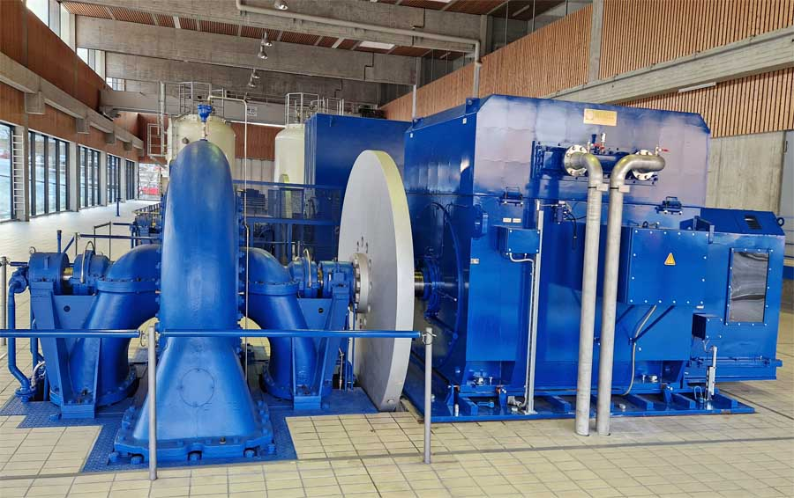
Caption: One-stop shop: Menzel built a slip-ring motor with a brush-lifting device, base frame, coupling and liquid starter, dismantled the old motor and installed and commissioned the new pump motor

Image/s: | pump_motor_w_brush_lifting_and_flywheel | Characters: | 1601
File name: | 202308004_pm_brush_lifting_pump_en | Date: | 11-09-2023
About Menzel Elektromotoren
Based in Berlin, Menzel Elektromotoren GmbH has been manufacturing and distributing electric motors since 1927. The medium-sized company specializes in the delivery of large electric motors, including special models, within the shortest possible time. The product range comprises high and low voltage motors, DC motors, transformers, and frequency inverters. Services include motor production and short-term adaptation of stocked motors to application-specific requirements. In order to ensure fast deliveries to the customer at all times, the company maintains a very extensive inventory including more than 20,000 motors with a maximum performance of up to 15,000 kW. Qualified engineering, experienced staff, and state-of-the-art production and testing facilities help Menzel provide excellent reliability. Menzel operates subsidiaries in the UK, France, Italy, Spain, and Sweden, and cooperates with numerous partners worldwide.
Menzel is currently building a new motor plant in Hennigsdorf, near Berlin. The future headquarters will go into operation in early 2024.
Contact:  Menzel Elektromotoren GmbH  Mathis Menzel  Neues Ufer 19 – 25  10553 Berlin  Germany  Phone: +49 30 349 922-0  Email: info@menzel-motors.com  Internet: www.menzel-motors.com |  | gii die Presse-Agentur GmbH  Immanuelkirchstr. 12  10405 Berlin  Germany  Phone: +49 30 538 965-0  Email: info@gii.de  Internet: www.gii.de

