Press Release

RAFI gains sustainability certification

Appraisal agency EcoVadis has awarded the RAFI Group a distinction in recognition of its sustainability and social responsibility (CSR) programs. The HMI solution provider has received the silver medal from the globally operating ratings platform. This puts RAFI in the top quarter of most sustainable companies according to the EcoVadis enterprise evaluation table. The relevant parameters are: environmental protection, corporate ethics, procurement, and labor and human rights. Throughout the group, RAFI strives for sustainable development and continuous improvement. Included here are the use of renewable energies in production, local procurement of raw materials as far as possible, resource-saving manufacturing, and proactive obsolescence management. The last point ensures customers can count on the long-term availability of reliable electronic products. Other factors praised by Ecovadis are for example good in-house further training opportunities and working conditions at RAFI.

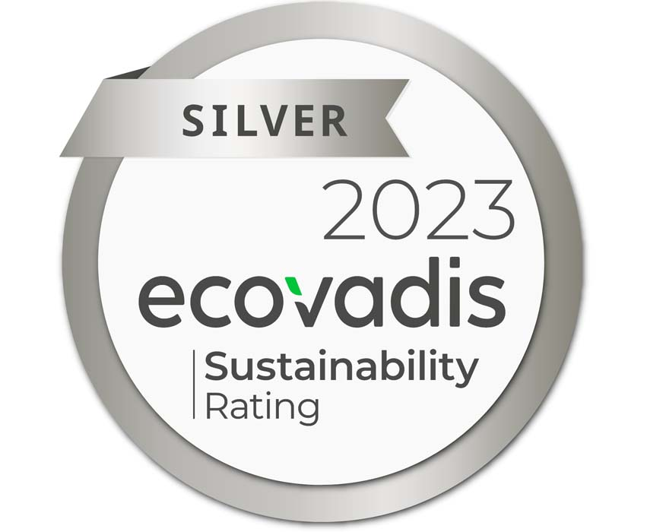
Caption: RAFI receives the EcoVadis silver medal for sustainability

With a number of major projects, RAFI is currently driving further sustainable company development. The group is investing a sum in the high two-digit millions in a renovation and energy-saving modernization project at the corporate headquarters in Berg. It is successively upgrading the business premises with new, climate-friendly roofs, façades, and glazing. Construction started in April on a new factory in Bad Waldsee, which will excel with energy-efficient, low-consumption building infrastructure. As a holder of the EcoVadis medal, RAFI has successfully passed the rating agency’s evaluation process, proving that it operates an effective management system with a focus on sustainability. The award also confirms that RAFI meets the licensing and approval criteria relevant for the industry. EcoVadis has performed over 1.6 m sustainability assessments to date and supports more than 100,000 companies worldwide with the evaluation and achievement of their sustainability, ESG, and compliance goals.
More information about sustainability at RAFI: https://www.rafi-group.com/en/company-career/sustainability/

Image/s: | rafi-logo.png  ecovadis_logo_2000px.jpg | Characters: | 2000
File name: | 202308012_pm_ecovadis_green_certification_en | Date: | 08-09-2023
About the RAFI group
Founded in 1900, RAFI today develops and produces electromechanical components and systems for human–machine interaction. The range of products includes key switches, switches, touchscreens, control systems and electronic assemblies. RAFI products are employed in many industries including automation, medical technology, machine and plant engineering, road and railway vehicles, household appliances and telecommunication. The RAFI group operates internationally with more than 2,000 employees at sites in Germany, Europe, China, and the USA. Its headquarters are in Berg, Germany.
Contact:
RAFI GmbH & Co. KG
Tatjana Schweitzer
Ravensburger Str. 128-134
88276 Berg, Germany
Phone: +49 751 89-1468
Email: tatjana.schweitzer@rafi-group.com
Internet: www.rafi-group.com

