Press Release

New MENZEL headquarters:
Larger plant for larger motors

At the new motor plant of Menzel Elektromotoren, which is currently being built in Hennigsdorf, near Berlin, Germany, the interior construction has now been completed on schedule. Moving to the new site with a total area of 24,000 m², the electric motor manufacturer will increase its floor space and capacities, optimize the factory layout for an efficient production flow and is planning to create additional jobs. The crane capacities will be increased to 80 tons and the entire shop floor will be accessible via two crane levels, which will bring significant logistical advantages.

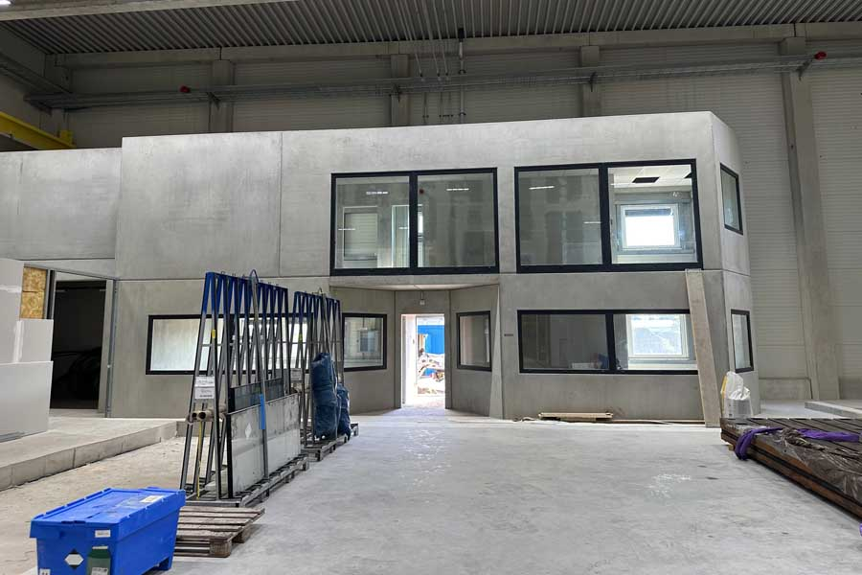
Caption: The new Menzel Elektromotoren plant is rapidly progressing towards its on-schedule completion (pictured: test field cabin with customer lounge)

In recent years, MENZEL has seen a growing demand for larger, more complex drive systems with a variety of auxiliary equipment such as transformers, converters, controllers and starters. The new test facilities are tailored to this need. For example, the area for load testing of large machines and generators has been significantly enhanced to cater for the largest frame sizes and loadings. A two-floor construction inside the load test field will house the control room, offices for the test field technicians and a separate lounge from which customers can observe ongoing tests. The soundproofing measures have been completed, and heavy-duty racks for shelf loads of 6,000 kg have been procured, which will accommodate part of the large MENZEL motor inventory and thus further shorten delivery times.
In the next few months, the gradual relocation from the existing headquarters in Berlin will commence. The production and shipping of industrial motors in the high output range will continue without interruption. The commissioning of the new company headquarters is scheduled for early 2024. MENZEL designs and manufactures its own efficient series of slip ring motors and squirrel-cage motors and also specializes in custom-made products, even with unusual specifications.
Photo construction diary for the new plant: https://www.menzel-motors.com/article/photo-report-new-electric-motor-plant/

Image/s: | test_field_cabin_under_construction | Characters: | 1862
File name: | 202308017_pm_new_motor_plant_interior_en | Date: | 08-22-2023
About Menzel Elektromotoren
Based in Berlin, Menzel Elektromotoren GmbH has been manufacturing and distributing electric motors since 1927. The medium-sized company specializes in the delivery of large electric motors, including special models, within the shortest possible time. The product range comprises high and low voltage motors, DC motors, transformers, and frequency inverters. Services include motor production and short-term adaptation of stocked motors to application-specific requirements. In order to ensure fast deliveries to the customer at all times, the company maintains a very extensive inventory including more than 20,000 motors with a maximum performance of up to 15,000 kW. Qualified engineering, experienced staff, and state-of-the-art production and testing facilities help Menzel provide excellent reliability. Menzel operates subsidiaries in the UK, France, Italy, Spain, and Sweden, and cooperates with numerous partners worldwide.
Menzel is currently building a new motor plant in Hennigsdorf, near Berlin. The future headquarters will go into operation in early 2024.
Contact:  Menzel Elektromotoren GmbH  Mathis Menzel  Neues Ufer 19 – 25  10553 Berlin  Germany  Phone: +49 30 349 922-0  Email: info@menzel-motors.com  Internet: www.menzel-motors.com |  | gii die Presse-Agentur GmbH  Immanuelkirchstr. 12  10405 Berlin  Germany  Phone: +49 30 538 965-0  Email: info@gii.de  Internet: www.gii.de

