Press Release

Empty mould check made even more comfortable

The German machine vision expert Bi-Ber has enhanced its empty mould check systems for confectionery production lines, adding multiple new functions. The teach-in of similar moulds is facilitated by allowing users to copy entire parameter sets for editing and adjusting. There is a new efficient automatic function for correct mould position detection, which also provides useful data to machine builders about potential belt elongation. At customer's request, the manufacturer has also added an archive function for browsing the most recent images with negative results. Bi-Ber offers a range of systems for optical empty mould check based on colour image processing. The inspection systems are installed directly above the conveyor and, working at line speed, check whether the moulds contain product residues, fragments or splashes. This eliminates the need for the elaborate production of mould-specific stamps and time-consuming mechanical checks. The series currently comprises four options for varying line layouts with limited available space, each of which can be designed for different mould widths. In addition, customer-specific adaptations and tailored inspection systems are possible. Cameras, lighting and a touch panel PC are integrated in a single or two separate stainless-steel cabinets, depending on the model. Thus, there are suitable solutions for retrofitting in existing production lines, too.

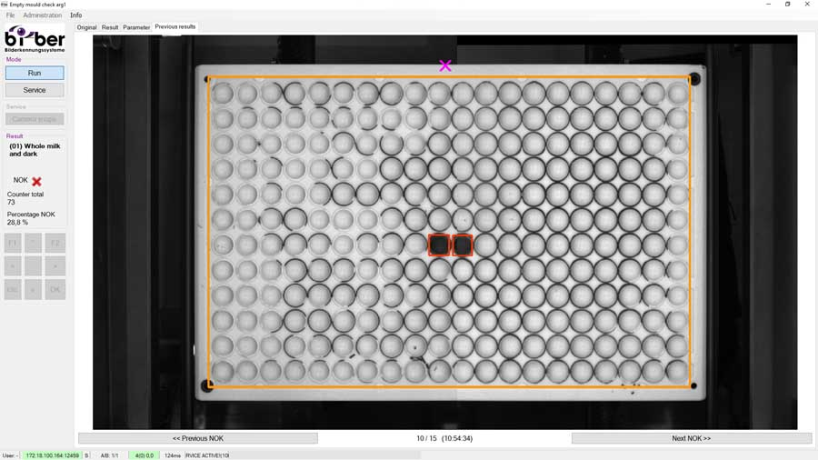
Caption: As a new function, users can browse the most recent error images in Bi-Ber empty mould check systems

Image/s: | empty_mould_check_nok_results | Characters: | 1417
File name: | 202309017_pm_empty_mould_check_en | Date: | 09-19-2023
About Bi-Ber
Founded in 1997 and based in Wildau, near Berlin, Bi-Ber develops and manufactures image processing systems for in-production quality control. The service range includes the construction of hardware components, on-site installation, commissioning, and adjustment of systems, as well as the development of application-specific software solutions. Bi-Ber currently employs a staff of seven and several freelancers. In addition to sweets manufacturers and OEMs working in the sweets industry, Bi-Ber supplies solutions for medical technology companies, printing industry, automotive suppliers, and electronics manufacturers.
Contact:  Bi-Ber GmbH & Co. Engineering KG  Ronald Krzywinski  Freiheitstr. 124/126  15745 Wildau  Germany  Phone: +49 . 30 . 810 322 260  Email: sales@bilderkennung.de  Internet: www.bilderkennung.de |  | gii die Presse-Agentur GmbH  Immanuelkirchstr. 12  10405 Berlin  Germany  Phone: +49 . 30 . 538 9650  Email: info@gii.de  Internet: www.gii.de

