Press Release

Camera enclosure configurator now with quote on demand

The autoVimation configurator guides users to suitable protective enclosures for a wide range of camera formats in just a few steps, including the adaptation to specific applications. Users can directly request a quote, which is usually sent by email in less than 24 hours on weekdays. Upon entering some basic parameters for the camera, lens and connector, the configurator automatically suggests the smallest suitable protective enclosure from the autoVimation portfolio. Users can customize the front lid and rear wall options and select feature options and accessories. The manufacturer offers a wide range of mounting accessories, heating and cooling devices and wind curtains for vision applications in extreme environments as well as various window materials, such as germanium for infrared cameras. The configuration result is displayed with the correct order number. There are direct links to the data sheets for all housing series and accessories. autoVimation has been designing and manufacturing enclosures and mounting solutions for machine vision applications for 15 years. The effective, industrial-grade products featuring high ingress protection save customers the time-consuming development of their own enclosures and brackets.
Link to the enclosure configurator: https://www.autovimation.com/en/enclosures-en/enclosure-configurator

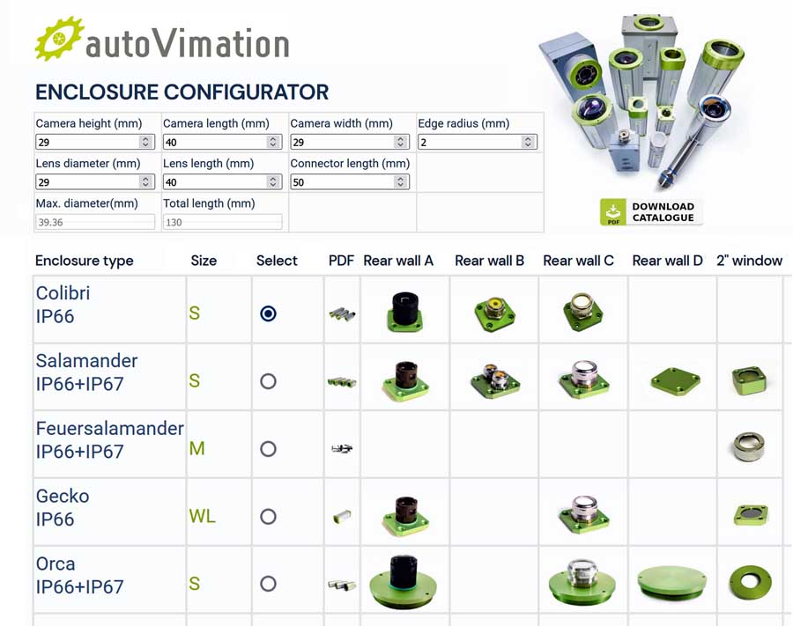
Caption: Enter just a few camera data to automatically find the right protective housing, then pick from a range of suitable accessories and request a quote

Image/s: | autovimation_configurator_en | Characters: | 1246
File name: | 202309022_pm_enclosure_configurator_en | Date: | 09-26-2023
About autoVimation
The German manufacturer autoVimation was founded in 2008 by Peter Neuhaus to provide solutions for easier installation and adjustment of image processing components. The company has developed a modular construction kit that simplifies the connection of all required components, which does away with costly and time-consuming manufacturing of dedicated mounting brackets. The product portfolio also includes compact, easy-to-integrate enclosures that provide optimal protection for cameras and lenses in industrial applications, and ensure good heat dissipation. autoVimation supplies complete, ready-to-install mechanical solutions for cameras and light fittings, and enables the integration of special lenses, filters, light barriers, encoders, or other sensors.
autoVimation's customers include renowned companies from various industry branches, such as the pharmaceutical and food industry, measuring technology, quality control, and security technology.
Contact:  autoVimation GmbH  Peter Neuhaus  Roemerweg 1  76287 Rheinstetten  Germany  Phone: +49 . 721 . 627 6756  Email: sales@autovimation.com  Internet: www.autovimation.com |  | gii die Presse-Agentur GmbH  Immanuelkirchstr. 12  10405 Berlin  Germany  Phone: +49 . 30 . 538 9650  Email: info@gii.de  Internet: www.gii.de

