Press Release

Pole mount for vision applications

autoVimation complements its mounting solutions for vision applications, introducing a pole mount that interfaces to existing wall mounts and mounting kits. Featuring two stainless-steel ribbon clips and a dovetail profile, the new fixture fits pole diameters up to 115 mm and almost all profile mounts in the manufacturer’s range. It provides a convenient and secure way to attach camera enclosures with dovetail profiles on poles, pipes and trusses with differently shaped cross sections. The manufacturer specializing in robust solutions to enable machine vision in harsh industrial environments and outdoors provides a comprehensive range of camera enclosures and mounting kits. Depending on the required degree of freedom, there is a choice of fixed brackets or versions that can be freely rotated along up to two axes. Users can flexibly combine adapter plates, clamps and brackets and thus position cameras and lasers with the right perspective for their various applications.
More about mounting kits from autoVimation: https://www.autovimation.com/en/mounting-accessories-en

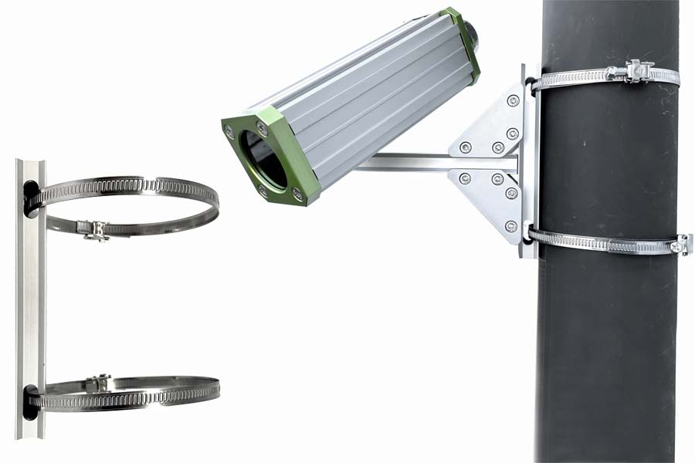
Caption: The pole mount enables secure attachment of camera mounts

Image/s: | autovimation_pole_mount | Characters: | 983
File name: | 202310008_pm_pole_mount_en | Date: | 10-17-2023
About autoVimation
The German manufacturer autoVimation was founded in 2008 by Peter Neuhaus to provide solutions for easier installation and adjustment of image processing components. The company has developed a modular construction kit that simplifies the connection of all required components, which does away with costly and time-consuming manufacturing of dedicated mounting brackets. The product portfolio also includes compact, easy-to-integrate enclosures that provide optimal protection for cameras and lenses in industrial applications, and ensure good heat dissipation. autoVimation supplies complete, ready-to-install mechanical solutions for cameras and light fittings, and enables the integration of special lenses, filters, light barriers, encoders, or other sensors.
autoVimation's customers include renowned companies from various industry branches, such as the pharmaceutical and food industry, measuring technology, quality control, and security technology.
Contact:  autoVimation GmbH  Peter Neuhaus  Roemerweg 1  76287 Rheinstetten  Germany  Phone: +49 . 721 . 627 6756  Email: sales@autovimation.com  Internet: www.autovimation.com |  | gii die Presse-Agentur GmbH  Immanuelkirchstr. 12  10405 Berlin  Germany  Phone: +49 . 30 . 538 9650  Email: info@gii.de  Internet: www.gii.de

