Press Release

RAFI: Innovative control concepts at the SPS

RAFI, one of the world’s leading suppliers of solutions for human-machine communication, will present a selection of its extensive product portfolio at this year’s SPS in Nuremberg from November 14 to 16. At its booth in Hall 8/128, the manufacturer will display not only a wide range of electromechanical actuators, but also haptic input solutions for touchscreen operation. The pushbuttons, rotary/push encoders and finger wheels from the FLEXSCAPE series are mounted on closed touchscreens without any need for cut-outs or holes. They enable tactile operation with haptic feedback and reliable finger guidance. Another RAFI focus at the SPS is the KIS.ME Plug&Play system for easy digital WLAN connection of previously unconnected work, logistics, and production areas. The KIS.ME hardware consists of control boxes with two illuminated pushbuttons which can be legended, as well as RGB signal lamps. The KIS devices are set up via the KIS.MANAGER web platform. They are individually configured by applying simple logical rules to trigger external events such as color states of the signal lamps or actively switched outputs from the control boxes. A virtual dashboard displays key figures and performance indicators. All connected KIS devices can be mapped as digital twins on a shopfloor plan and controlled via their digital equivalents. The third RAFI focus at the trade show is the company’s comprehensive electronic engineering and manufacturing services. As one of Germany’s ten largest E²MS suppliers, RAFI covers the entire contract production process – starting with material procurement, through PCB assembly, creation and implementation of test concepts, right up to logistics and life-cycle services. The RAFI team of experts is looking forward to welcoming lots of trade visitors to its SPS booth in Hall 8/128.

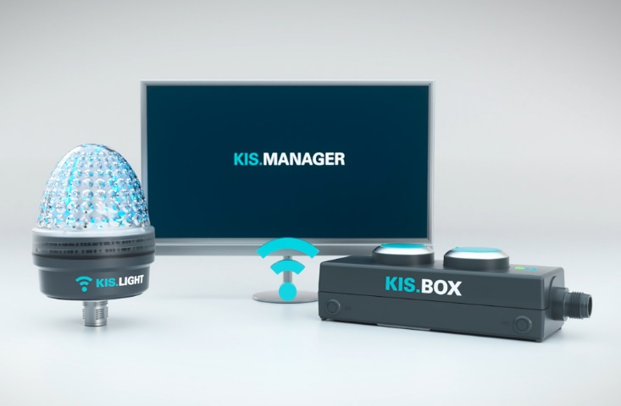

Caption: KIS.ME from RAFI: simple Plug&Play solution for rapid digitalization of previously unconnected work areas

Image/s: | kisme-devices_2000px.jpg | Characters: | 1,980
File name: | 202310012_pm_sps23_en.docx | Date: | 10-26-2023

About the RAFI group
Founded in 1900, RAFI today develops and produces electromechanical components and systems for human–machine interaction. The range of products includes key switches, switches, touchscreens, control systems and electronic assemblies. RAFI products are employed in many industries including automation, medical technology, machine and plant engineering, road and railway vehicles, household appliances and telecommunication. The RAFI group operates internationally with more than 2,000 employees at sites in Germany, Europe, China, and the USA. Its headquarters are in Berg, Germany.

Contact:  RAFI GmbH & Co. KG  Tatjana Schweitzer  Ravensburger Str. 128–134  88276 Berg, Germany  Phone: +49 751 89-1468  Email: tatjana.schweitzer@rafi-group.com  Web: www.rafi-group.com |  | gii die Presse-Agentur GmbH  Immanuelkirchstr. 12  10405 Berlin, Germany  Phone: +49 30 53 89 65-0  Email: info@gii.de  Web: www.gii.de

