Press Release

Agritechnica: Versatile touch control solutions from RAFI

At the Agritechnica 2023 in Hanover from November 12 to 18, RAFI will highlight new developments and innovative solutions for the effective control of agricultural machinery and vehicles. The company will present its product and service portfolio on Stand D27 in Hall 17. There will be a particular focus on RAFI’s state-of-the-art, rugged GLASSCAPE control systems. The capacitive touchscreens come with impact-resistant glass panels, high protection ratings up to IP68, and finely-tuned sensors. The glass sensors can also be used with gloves, and special filter algorithms prevent false actuation triggered by accidental touch. The optical bonding used in these systems guarantees optimal display quality and legibility even in difficult light conditions such as direct sunlight. Even without visual contact, operators of mobile machinery and vehicles can rely on tactile feedback and precise finger guidance that allow them to fully concentrate on their surroundings. Haptic elements from the FLEXSCAPE series – pushbuttons, rotary/push encoders, and finger wheels – are mounted on the touchscreens without any need for cut-outs or holes. This creates adaptive operating systems with perfect functionality, and the display surface remains fully stable and tight. Displays with TWIN TOUCH technology combine touch and force sensitivity. Manufacturers can define the specific pressures required to actuate the various operating elements. This combination makes it possible to implement a functionally reliable touchscreen up to AgPL d. The HAPTIC TOUCH system provides a parameterizable force feedback for accurate conveyance of the tactile specifics of all tactile switches, sliders, and other input elements. RAFI can also customize these systems with a wide range of FLEXSCAPE actuators. The RAFI trade show crew is looking forward to exciting talks and expert discussions during the event.
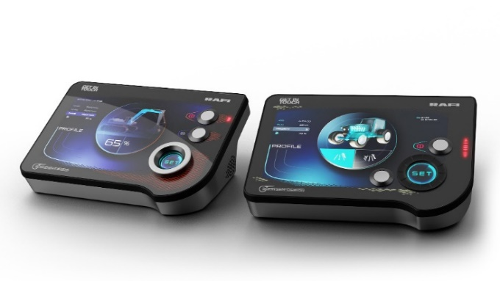

Caption: One highlight of the RAFI presentation at the Agritechnica: force-feedback touchscreens from the HAPTIC TOUCH range

Image/s: | rafi_glasscape_2000px.jpg | Characters: | 1,896
File name: | 202310013_pm_agritechnica23_en.docx | Date: | 10-24-2023

About the RAFI group
Founded in 1900, RAFI today develops and produces electromechanical components and systems for human–machine interaction. The range of products includes key switches, switches, touchscreens, control systems and electronic assemblies. RAFI products are employed in many industries including automation, medical technology, machine and plant engineering, road and railway vehicles, household appliances and telecommunication. The RAFI group operates internationally with more than 2,000 employees at sites in Germany, Europe, China, and the USA. Its headquarters are in Berg, Germany.

Contact:  RAFI GmbH & Co. KG  Tatjana Schweitzer  Ravensburger Str. 128–134  88276 Berg, Germany  Phone: +49 751 89-1468  Email: tatjana.schweitzer@rafi-group.com  Web: www.rafi-group.com |  | gii die Presse-Agentur GmbH  Immanuelkirchstr. 12  10405 Berlin, Germany  Phone: +49 30 53 89 65-0  Email: info@gii.de  Web: www.gii.de

