Press Release

Highly functional safety tester according to the latest standards

Since the end of the transition period in September 2023, periodic testing of electrical equipment must comply with DIN EN 50699 requirements. Gossen Metrawatt has a future-proof solution on hand and offers the latest generation of its SECUTEST ST device tester series at particularly attractive conditions. The safety testers with a distinctive lemon green housing design integrate all currently required test sequences according to DGUV Regulation 3 and MPBetreibV (German Medical Device Directive). They simplify professional, standard-compliant periodic testing for electrical safety per DIN EN 50699. This makes the series ideal for use in industry, trade and public institutions, for example. The measuring range includes the testing of protective conductor and insulation resistance, various leakage currents as well as SELV and PELV (safety/protective extra-low voltages). In addition, the devices can be used to check the time to trip for portable residual current devices (PRCD), functional tests of U, I, P, S, LF, f and cable tests for continuity, short circuiting and polarity. Automatic and individual test sequences ensure an effective and safe implementation of the standards. A practical rotary switch, direct selection keys and soft keys enable intuitive and reliable access to all test functions. Gossen Metrawatt supplies the tester in a bundle with an EL1 adapter, barcode reader and including a Business Professional license for the IZYTRONIQ software for networked, cross-device test data management.

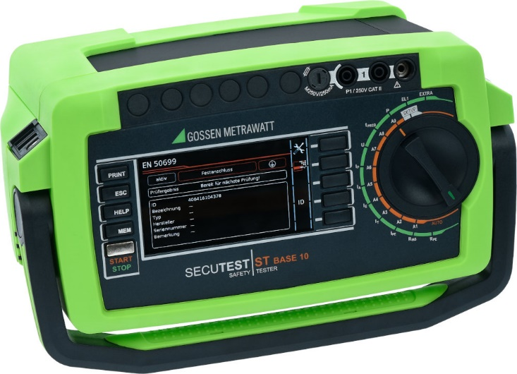
Caption 1: The new SECUTEST ST installation tester in the distinctive lemon green design meets the latest requirements for testing electrical safety

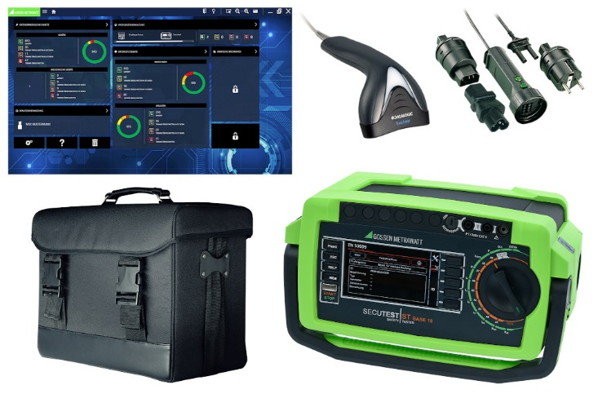
Caption 2: Gossen Metrawatt offers its new SECUTEST ST installation testers as an attractive package solution with case, adapters, probe, barcode reader and IZYTRONIQ Business license

Image/s: | secutest-st-base10  secutest-st-base10-comfortpaket | Characters: | 1523
File name: | 202311011_pm_secutest_st_lemon_en | Date: | 11-09-2023
About Gossen Metrawatt
Gossen Metrawatt, one of the world’s leading suppliers of measurement systems, develops and distributes a wide range of high-quality measuring and test devices for electrical trade, various industries and the public sector.
The Gossen Metrawatt brand has been synonymous with safety and quality “Made in Germany” for decades. Its product range includes measurement and test technology for the electrical safety of plants, devices and machines as well as for the e-mobility and medical technology industries. Additional key areas of interest are power quality, battery testing technology, multimeters, calibrators, power supply technology and energy management systems. For a truly comprehensive electrical safety portfolio, Gossen Metrawatt also offers a continuously growing range of digital services and cloud services and supports its customers with a versatile training program and a wide range of after-sales services.
Gossen Metrawatt is part of the GMC Instruments Group, which also includes other specialized manufacturers for measurement and testing technology – notably, Camille Bauer Metrawatt, Dranetz, Prosys, Seaward and Rigel and Kurth Electronic. The Camille Bauer and Rigel brands add to the portfolio various transducers, display instruments and detection systems for heavy-current engineering as well as special measuring, testing and functional testing devices for the medical sector. The GMC-I Group runs its own DAkkS-certified calibration center that performs DAkkS, ISO and factory calibrations for virtually all electrical measured quantities. The GMC-I Group has development and production sites in Germany, Switzerland, England and the USA and a worldwide sales network of its own companies as well as sales partners.
Contact:  Gossen Metrawatt GmbH  Christian Widder  Head of Marketing Communication  Suedwestpark 15  90449 Nuremberg  Germany  Phone: +49 . 911 . 8602-572  Email: christian.widder@gossenmetrawatt.com  Internet: www.gossenmetrawatt.com |  | gii die Presse-Agentur GmbH  Immanuelkirchstr. 12  10405 Berlin  Germany  Tel.: +49 . 30 . 538 9650  Email: info@gii.de  Internet: www.gii.de

