Press Release

Versatile smart label printing system for wire, terminal and cable marking

As one of the leading connection technology manufacturers, Conta-Clip has a labeling system on offer that meets all kinds of marking requirements: the compact and versatile thermal transfer printer TTPCardMax from the Conta-Label product range ensures excellent print quality and high resolution, suitable for all marking requirements in the electrical sector. The efficient printing system with proven thermal transfer technology quickly and reliably creates clear and durable inscriptions on labels and signs in a wide range of materials, such as PVC, PMMA, polyester, ABS or polycarbonate. TTPCardMAX thus ensures the long-lasting marking of terminal blocks, cables and wires, input and output devices, external control panels, switching modules and many other components. The printing software is tailored to the marker cards, with templates for all materials, and allows for simple and intuitive operation. The labeling system has a semi-automatic and an automatic feeder for fast processing with up to 5500 markers per hour. The low-maintenance and easy-to-use system requires little attention: the easily accessible print and feed area allows for an easy exchange of ribbon cartridges. A cleaning cartridge for automatic printer cleaning increases print quality. The easy-to-use ContaPrintMAX software for Windows operating systems allows users to edit and print labels for single, multiple or serial marking with ease. The software enables easy and fast processing of print data and has been specially developed for professional marking of machines, systems and control cabinets.

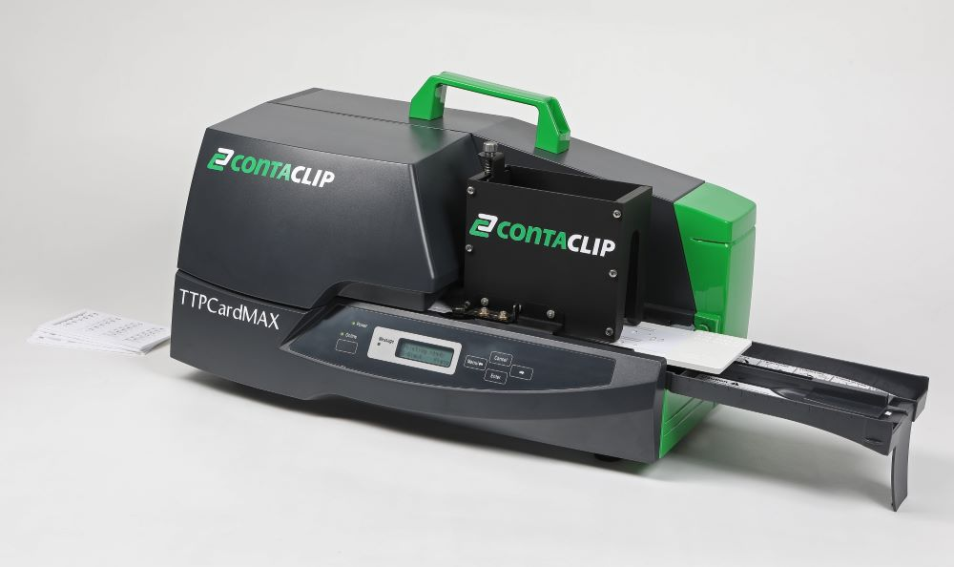
Caption: Conta-Clip provides a versatile, easy-to-use label printing system for electric and electronic connection technology: TTPCardMAX

(box)
Smart solutions for the world of tomorrow
"Inside the smartest workflows" – that is the claim to which Conta-Clip is committed: to be at the core of every smart connection, a driving force for streamlined work and more productivity – worldwide. The company develops and manufactures products for almost all industrial sectors. Whether in mechanical and plant engineering, transport and process engineering, cleanroom technology or renewable energies – the German manufacturer stands for high-quality electrical and electronic connection technology in all these industries. In addition to product development, the specialist for wiring technology and cable management invests in modern and efficient production processes according to strict ecological and sustainable criteria.

Conta-Clip at the SPS trade fair
Nuremberg, Germany, 14 – 16 November 2023
Hall 10, Stand 122

Image/s: | TTPCardMAX | Characters: | 1587  +734
File name: | 202311014_pm_conta-label_ttpcardmax_en | Date: | 11-09-2023
About CONTA-CLIP
CONTA-CLIP is one of Europe’s leading manufacturers of electrical and electronic connection elements and cable management solutions. Based in Hövelhof, Germany, the medium-sized, family-run company has been producing electric and electronic connection systems for the process and automation industries since 1978. CONTA-CLIP supplies all industry sectors, focusing on railroad industries, shipbuilding, building automation, conveyor technology, machine and plant engineering and construction, instrumentation and control technology, control panel manufacturing, transformer manufacturing, and environmental technology. The company consists of many specialized branches: CONTA-CONNECT for electric connection technology, CONTA-CABLE for cable management systems, CONTA-ELECTRONICS for electronics and CONTA-CON for PCB edge connectors. Additionally, CONTA-CLIP provides services such as customizing housings and mounting rails, labeling and supplying user-specific electronic components.
Contact:  CONTA-CLIP  Verbindungstechnik GmbH  Franziska Klein  Otto-Hahn-Str. 7  33161 Hövelhof  Germany  Phone: +49 . 5257 . 9833 - 173  Fax: +49 . 5257 . 9833 - 33  Email: franziska.klein@conta-clip.de  Internet: www.conta-clip.com |  | gii die Presse-Agentur GmbH  Immanuelkirchstr. 12  10405 Berlin  Germany  Phone: +49 . 30 . 538 965 - 0  Fax: +49 . 30 . 538 965 - 29  Email: info@gii.de  Internet: www.gii.de

