Press Release

Modular armrest control system in twelve configuration levels

RAFI has developed a multifunction armrest control system for the new tractor generation from agricultural machinery manufacturer Massey Ferguson, a member of the ACGO Group. The scalable solution is available in a wide range of variants so that customers can choose between twelve configuration levels with different function ranges and joystick features. To achieve this high degree of customization, RAFI designed around 80 new injection molding tools and set up a production line with a new assembly process. In the one-piece-flow process, one assembly worker assembles the entire armrest along all stations, supported by visual instructions and pick-by-light technology. All the components and work steps can be seamlessly tracked. RAFI manufactures the armrests almost exclusively using in-house developed technologies, product groups, and its own production processes. The armrest system was developed in accordance with DIN EN ISO 25119 – AgPL c. Safety-critical operating elements for the vehicle and hydraulic control system feature a redundantly designed hardware as well as diagnosis-capable software to reliably maintain error-free functionality. The up to four integrated joystick variants are based on different JOYSCAPE technology platforms developed by the HMI expert. Contactless, wear-free Hall sensors take care of motion detection. They have an operating life of at least five million actuation cycles. Integrated shield plates protect the sensors against any influence from external magnetic fields. Innovative single-axis linear joysticks with latching function are available for the control of additional hydraulic functions. The silicone keypads contain RAFI MICON 5 tactile switches. Arranged in an ultra-compact row of pushbuttons, they deliver distinct tactile feedback. High-quality gold contacts ensure permanent switching reliability. For safety-critical functions, RAFI uses its fail-safe, redundantly designed MICON 5 Safety micro-switches.

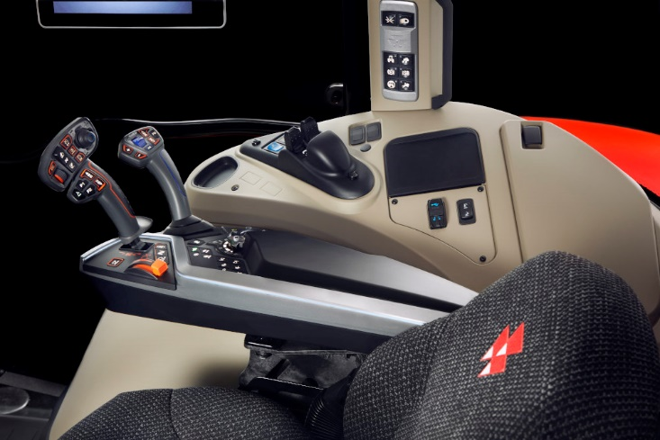

Caption: Multifunction armrest control system from RAFI in twelve configuration levels for the new generation of Massey Ferguson tractors

Image/s: | mf_7s_armrest_2000px.jpg | Characters: | 2,128
File name: | 202311024_pm_mf-armrest_en.docx | Date: | 11-28-2023

About the RAFI group
Founded in 1900, RAFI today develops and produces electromechanical components and systems for human–machine interaction. The range of products includes key switches, switches, touchscreens, control systems and electronic assemblies. RAFI products are employed in many industries including automation, medical technology, machine and plant engineering, road and railway vehicles, household appliances and telecommunication. The RAFI group operates internationally with more than 2,000 employees at sites in Germany, Europe, China, and the USA. Its headquarters are in Berg, Germany.

Contact:  RAFI GmbH & Co. KG  Tatjana Schweitzer  Ravensburger Str. 128–134  88276 Berg, Germany  Phone: +49 751 89-1468  Email: tatjana.schweitzer@rafi-group.com  Web: www.rafi-group.com |  | gii die Presse-Agentur GmbH  Immanuelkirchstr. 12  10405 Berlin, Germany  Phone: +49 30 53 89 65-0  Email: info@gii.de  Web: www.gii.de

