Press Release

Metal detection with increased sensitivity

EGE presents the improved MDVH 3261 amplifier for its System 3000 metal detectors for metal detection in conveyed goods. The new evaluation electronics with increased sensitivity opens up additional application areas. A diagnostic LED now enables faster commissioning. A new "test" button can be used to check the system's proper function at any time. Featuring automatic self-calibration, the unit works reliably even if the detector coil comes near metal fittings. EGE metal detection systems consist of one or two detector coils and an amplifier. They reliably detect and report metallic objects on conveyor belts before these can cause costly damage. Users can adjust the system's sensitivity and size of the detectable objects by means of a potentiometer on the amplifier. EGE has designed the System 3000 metal detector range for robust performance in harsh and dirty outdoor environments. The size of detected parts varies with different amplifier models. The MDVH series is used to detect medium-sized parts. MDV devices detect larger metal parts, such as excavator shovel teeth, tools or bits of cladding. The IP67-rated evaluation units can be installed on or near the conveyor or at a distance in the control room. All control and display components are protected, located under a lid.
More about the metal detector system: https://www.ege-elektronik.com/products/metal-detector-system-3000

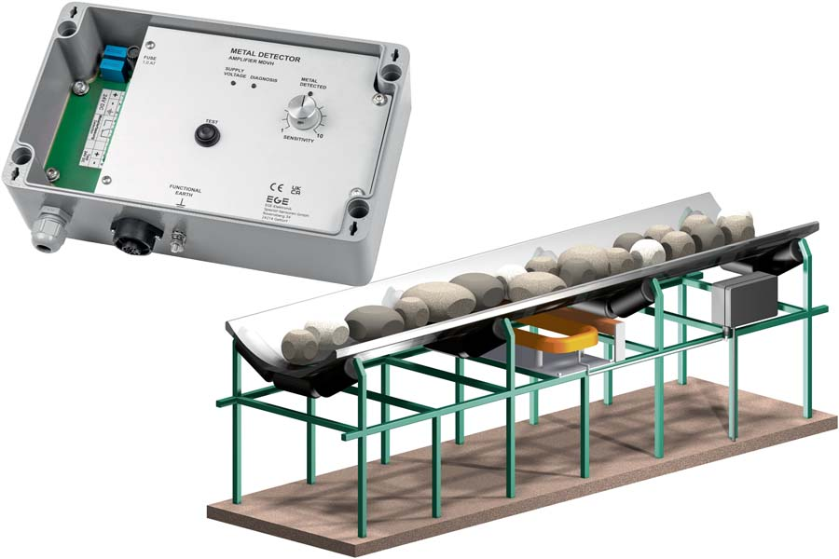
Caption: EGE continues to enhance its System 3000 metal detector range and presents the new MDVH 3261 amplifier with increased sensitivity

Image/s: | system_3000_mdvh_metal_detector | Characters: | 1296
File name: | 202311025_pm_mdvh_amplifier_en | Date: | 11-28-2023
About EGE
EGE-Elektronik Spezial-Sensoren GmbH has been developing and manufacturing special purpose sensors for automation applications since 1976. The company serves leading international producers from a wide range of industries. Its product portfolio includes flow controllers, infrared, opto and ultrasonic sensors, capacitive proximity switches, light barriers and inductive proximity switches. EGE also provides sensors for highly sensitive applications, e.g. hazardous areas. The development department's highly qualified staff cooperates closely with all customers, ensuring continuous product updates and enhancement. A total of 130 employees, including 20 engineers and technicians, generate gross sales of approx. 19.5 million Euros worldwide.
Contact:  EGE-Elektronik Spezial-Sensoren GmbH  Sven-Eric Hiss  Ravensberg 34  24214 Gettorf  Germany  Phone: +49 . 4346 . 4158-0  Email: info@ege-elektronik.com  Internet: www.ege-elektronik.com |  | gii die Presse-Agentur GmbH  Immanuelkirchstr. 12  10405 Berlin  Germany  Phone: +49 . 30 . 538 9650  Email: info@gii.de  Internet: www.gii.de

