Press Release

Flow sensors with IO-Link interface for 0.5 to 100 l/min

EGE expands its range of IO-Link sensors, launching an entire new series of flow sensors for smart networking in compact plants and systems. The new SDNB 552 series is based on a tried and tested special model. Four series sensors measure the flow velocity and temperature of water-based liquids in ranges between 0.5... 10 l/min and 5... 100 l/min with linearized measured value output. The IO-Link interface allows for convenient remote sensor parameterization and data read out for maintenance. The analog output and switching output are available in SIO mode. Parameterization with IO-Link via the M12 connection is carried out either via a PLC or an IO-Link master – EGE offers the IOL Master Set V1.1 for this purpose. The sensors featuring G1/2 or G3/4 connection threads are designed for inline mounting in hoses and pipes. Based on the calorimetric measuring principle, the sensors introduce no moving parts or deflectors into the stream. The wetted parts are made of 1.4571 stainless steel. The sensors are IP65-rated, pressure-resistant up to 10 bar and designed for media temperatures from 0 °C to 60 °C. Due to their rugged design, EGE flow sensors withstand moisture and vibrations.
More about the series: https://www.ege-elektronik.com/products/sdnb-552-1

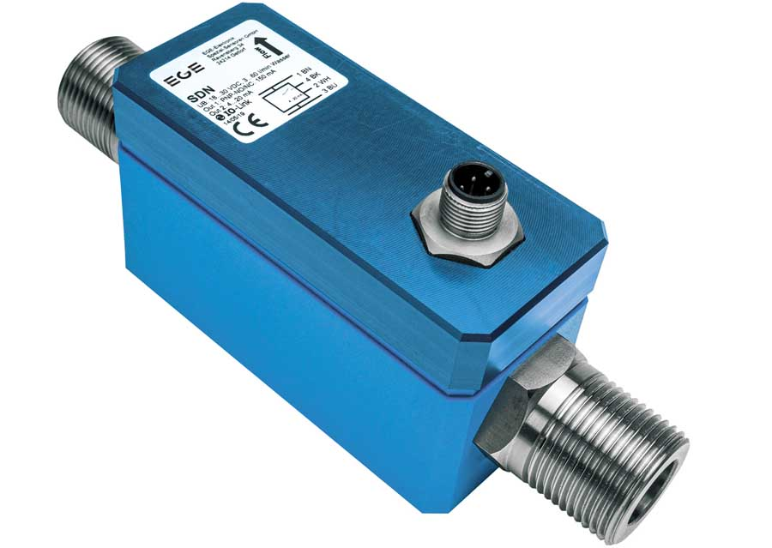
Caption: Introducing the SDNB flow sensor series, EGE enables reliable monitoring of flow and media temperature with remote parameterization via IO-Link

Image/s: | sdnb_552_io-link_flow_sensor | Characters: | 1196
File name: | 202311026_pm_sdnb_io-link_flow_sensor_en | Date: | 12-05-2023
About EGE
EGE-Elektronik Spezial-Sensoren GmbH has been developing and manufacturing special purpose sensors for automation applications since 1976. The company serves leading international producers from a wide range of industries. Its product portfolio includes flow controllers, infrared, opto and ultrasonic sensors, capacitive proximity switches, light barriers and inductive proximity switches. EGE also provides sensors for highly sensitive applications, e.g. hazardous areas. The development department's highly qualified staff cooperates closely with all customers, ensuring continuous product updates and enhancement. A total of 130 employees, including 20 engineers and technicians, generate gross sales of approx. 19.5 million Euros worldwide.
Contact:  EGE-Elektronik Spezial-Sensoren GmbH  Sven-Eric Hiss  Ravensberg 34  24214 Gettorf  Germany  Phone: +49 . 4346 . 4158-0  Email: info@ege-elektronik.com  Internet: www.ege-elektronik.com |  | gii die Presse-Agentur GmbH  Immanuelkirchstr. 12  10405 Berlin  Germany  Phone: +49 . 30 . 538 9650  Email: info@gii.de  Internet: www.gii.de

