Press Release

Application-specific magnetic sensors for extreme conditions

EGE-Elektronik launches magnetic sensors for use in cryogenic processes in medical technology and beyond. The MGK series sensors are employed in dry cryogenic atmospheres, for example to detect, count or position containers, flaps, doors or valves. The German manufacturer adapts the sensors to customer-specific requirements, on request. The MGKP series featuring special materials is suitable for continuous operation at temperatures down to -80 °C. The magnetic sensors switch when they near a surface with a neodymium magnet, for example on a transport container or a flap. The sensing distance is 5...20 mm, depending on the flux density of the neodymium magnet. The use of magnetic sensors enables increased sensing distances even at extreme temperatures and temperature profiles that challenge inductive sensors. They also detect objects through non-magnetic materials such as plastic walls.

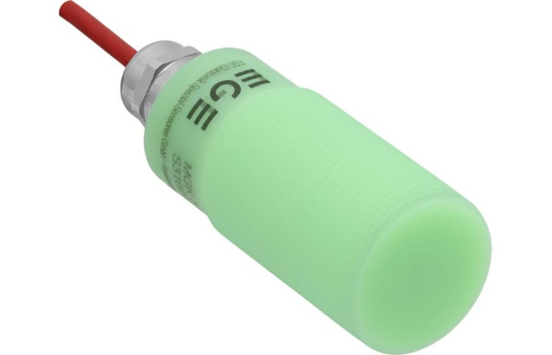
Caption: MGK-type magnetic sensors from EGE-Elektronik detect objects and monitor the opening and closing of flaps and doors in cryogenic processes

Image/s: | mgk_magnetic_sensor | Characters: | 898
File name: | 202311028_pm_mgk_magnetic_sensors_en | Date: | 11-13-2023
About EGE
EGE-Elektronik Spezial-Sensoren GmbH has been developing and manufacturing special purpose sensors for automation applications since 1976. The company serves leading international producers from a wide range of industries. Its product portfolio includes flow controllers, infrared, opto and ultrasonic sensors, capacitive proximity switches, light barriers and inductive proximity switches. EGE also provides sensors for highly sensitive applications, e.g. hazardous areas. The development department's highly qualified staff cooperates closely with all customers, ensuring continuous product updates and enhancement. A total of 130 employees, including 20 engineers and technicians, generate gross sales of approx. 19.5 million Euros worldwide.
Contact:  EGE-Elektronik Spezial-Sensoren GmbH  Sven-Eric Hiss  Ravensberg 34  24214 Gettorf  Germany  Phone: +49 . 4346 . 4158-0  Email: info@ege-elektronik.com  Internet: www.ege-elektronik.com |  | gii die Presse-Agentur GmbH  Immanuelkirchstr. 12  10405 Berlin  Germany  Phone: +49 . 30 . 538 9650  Email: info@gii.de  Internet: www.gii.de

