Press Release

New Menzel motor plant completed

The new Menzel Elektromotoren headquarters on the outskirts of Berlin are ready for occupation. All works were completed on time and on budget – a remarkable feat of coordination between all trades and partner companies. The move has already started; the relocation of the large stock of motors and accessories, in particular, will take some time – Menzel maintains one of the largest warehouses for large electric motors in Europe, which ensures short-term delivery capability at all times. Production and administration are also moving into the new building gradually. Operations will officially start on January 2, 2024. CEO Mathis Menzel is looking forward to it: “This move will ring in a new era in the history of our family business. The new plant is tailored to our requirements in every detail: generously proportioned logistics and production areas, continuous crane accessibility with an 80-ton lifting capacity – that will enable us to achieve streamlined production processes, to schedule and complete customer projects even more flexibly and reliably, and it will properly set us up for the future as the international headquarters of our group.”

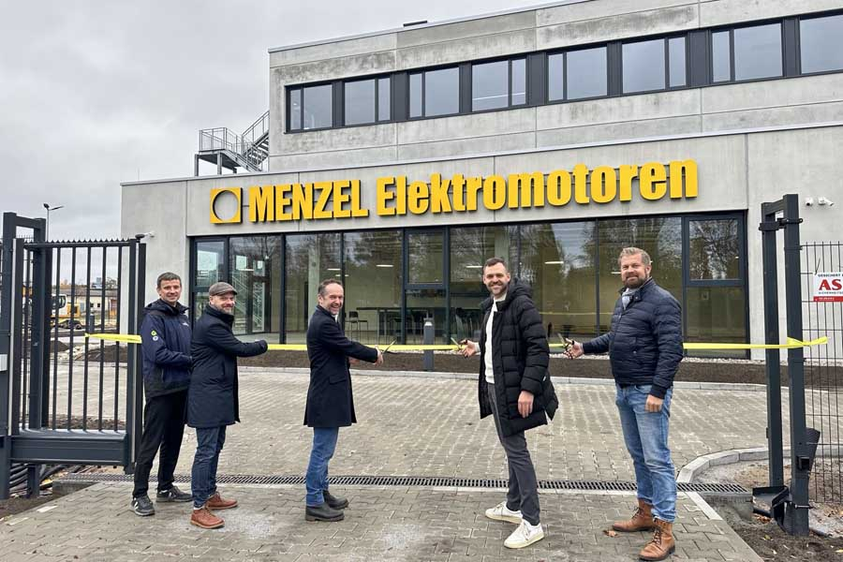
Caption: Ribbon-cutting ceremony for the new Menzel headquarters with Thomas Schreck and Matthias Jordt from the general contractor Vollack and, representing Menzel: Dirk Achhammer, Paul Bernhardt and Mathis Menzel (from left to right)

Menzel is a medium-sized manufacturer and worldwide supplier of three-phase asynchronous motors with squirrel cage or slipring rotors up to 15 MW and, in special versions, up to 25 MW. In addition to standard motors with excellent performance properties, the manufacturer specializes in customer-specific and tailored drive solutions.
Photo construction diary for the new plant: https://www.menzel-motors.com/article/photo-report-new-electric-motor-plant/

Image/s: | hennigsdorf_ribbon_cutting |  | Characters: | 1494
File name: | 202311031_pm_hennigsdorf_ribbon_cutting_en |  | Date: | 11-22-2023
About Menzel Elektromotoren
Menzel Elektromotoren GmbH has been manufacturing and distributing electric motors since 1927. The medium-sized company specializes in the delivery of large electric motors, including special models, within the shortest possible time. The product range comprises high and low voltage motors, DC motors, transformers, and frequency inverters. Services include motor production and short-term adaptation of stocked motors to application-specific requirements. In order to ensure fast deliveries to the customer at all times, the family-run company maintains a very extensive inventory including more than 20,000 motors with a maximum performance of up to 15,000 kW. Qualified engineering, experienced staff, and state-of-the-art production and testing facilities help Menzel provide excellent reliability. Menzel operates subsidiaries in the UK, France, Italy, Spain, and Sweden, and cooperates with numerous partners worldwide.
Menzel is leaving its established headquarters in the center of Berlin and moving to the outskirts of the German capital. At the start of 2024, Menzel will start operations at its new motor plant in Hennigsdorf.
Contact:  Menzel Elektromotoren GmbH  Mathis Menzel  Neues Ufer 19 – 25  10553 Berlin  Germany  From January 1:  Am Alten Walzwerk 2  16761 Hennigsdorf, Germany  Phone: +49 30 349 922-0  Email: info@menzel-motors.com  Internet: www.menzel-motors.com |  | gii die Presse-Agentur GmbH  Immanuelkirchstr. 12  10405 Berlin  Germany  Phone: +49 30 538 965-0  Email: info@gii.de  Internet: www.gii.de

