Press Release

TÜV certification for Ex p motors

Menzel Elektromotoren has been certified for the production of large squirrel-cage motors in ignition protection type Ex p pressurization for operation in zone 1 hazardous areas where an explosive gas/air mixture is likely to occur in normal operation. The test specimen, a compressor motor for the petroleum industry, underwent a gas displacement test (test of the air purge system), leak test and pressure test. The German technical inspection service TÜV Nord comprehensively tested and certified the construction method. To win the approval, the manufacturer had to prove its ability to control the purging air flow for all its relevant motor series in such a way that no gas pockets remain inside the motor casing. Menzel can apply this manufacturing procedure to stock motors in a wide output range and is thus able to flexibly and quickly provide competitively priced Ex p motors featuring the product categories 2G and 3G. Pressurized motor construction is typically suitable for squirrel-cage motors from 400 mm shaft height. It is available for all voltage ranges and with air-to-air or air-to-water heat exchangers (cooling types IC 611, IC 616 or IC 81W).

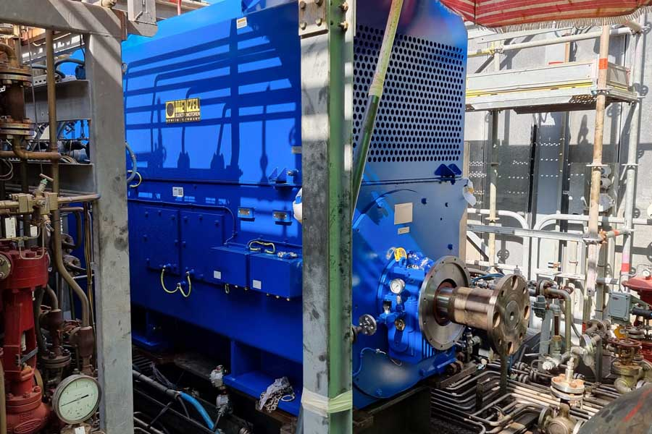
Caption: Menzel can quickly configure squirrel-cage motors in ignition protection type Ex p pressurization, product categories 2G and 3G and in a wide output range from stock (pictured: Ex p compressor motor for an oil refinery)

An air-purge system allows potentially flammable gases to be removed from the motor frame before the motor is started and to maintain a constant positive pressure during operation to prevent the ingress of explosive gases. The terminal boxes feature the ignition protection type Ex eb increased safety.
Plant operators often face the challenge that they cannot find suitable replacements for obsolete motors. The choice of explosion-proof drive systems in particular is limited. Up until now, the only alternative was to buy a standard motor with the required explosion-protection rating and adapt the installation site and/or driven machine, sometimes at considerable time and expense. Menzel's certification for the construction and manufacture of protected motors now gives customers more freedom of choice and flexibility. The German manufacturer specializing in large electric motors always configures motors for the individual application and installation conditions. Likewise, the air purge system for pressurized motors is individually calculated and implemented, ensuring that the finished systems meet the highest safety standards.
For a petrochemical company, Menzel has recently manufactured an Ex p compressor motor based on its MEBKSL series, which matches the original motor in all mechanical and electrical interfaces. The compressor motor for an oil refinery is labeled II 3G Ex pzc ec ic IIC T3 Gc for zone 2. It has a rated voltage of 6000 V and a rated output of 1635 kW. Before shipping, the motor was rigorously tested in the company's inhouse test facility, including load and type testing.
Menzel's Ex p motors were named the Product of the Year in the 2023 AEMT Awards.
Product website: https://www.menzel-motors.com/pressurized-exp-motors-zone1-operation/

Image/s: | ex_p_motor | Characters: | 2838
File name: | 202311032_pm_ex_p_motors_en | Date: | 12-07-2023
About Menzel Elektromotoren
Menzel Elektromotoren GmbH has been manufacturing and distributing electric motors since 1927. The medium-sized company specializes in the delivery of large electric motors, including special models, within the shortest possible time. The product range comprises high and low voltage motors, DC motors, transformers, and frequency inverters. Services include motor production and short-term adaptation of stocked motors to application-specific requirements. In order to ensure fast deliveries to the customer at all times, the family-run company maintains a very extensive inventory including more than 20,000 motors with a maximum performance of up to 15,000 kW. Qualified engineering, experienced staff, and state-of-the-art production and testing facilities help Menzel provide excellent reliability. Menzel operates subsidiaries in the UK, France, Italy, Spain, and Sweden, and cooperates with numerous partners worldwide.
Menzel is leaving its established headquarters in the center of Berlin and moving to the outskirts of the German capital. At the start of 2024, Menzel will start operations at its new motor plant in Hennigsdorf.
Contact:  Menzel Elektromotoren GmbH  Mathis Menzel  Neues Ufer 19 – 25  10553 Berlin  Germany  From January 1:  Am Alten Walzwerk 2  16761 Hennigsdorf, Germany  Phone: +49 30 349 922-0  Email: info@menzel-motors.com  Internet: www.menzel-motors.com |  | gii die Presse-Agentur GmbH  Immanuelkirchstr. 12  10405 Berlin  Germany  Phone: +49 30 538 965-0  Email: info@gii.de  Internet: www.gii.de

