Press Release

Five types of application-specific SPE cables

Extending its CATLine product series, SAB Bröckskes has launched application-tailored Single-Pair Ethernet (SPE) cables in five variants. A member of the SPE network, the special cable manufacturer drives the further development of this technology. Compared to conventional 4-pair Ethernet connections, SPE offers significant savings potential in material, space and costs as high data rates can be transmitted over long distances with just one pair of copper cores. The CATLine SPE cables newly developed by SAB Bröckskes can withstand high mechanical loads and temperatures and are highly resistant to chemicals, oils and cleaning agents. The portfolio includes the two variants CATLine SPE C-Track and SPE Robot, which are optimized for increasing data transmission rates in automation applications. The CATLine SPE C-Track cable, which is specified for drag chain use, features a permanently flexible design and an especially adapted stranding technology. The version for robot use is characterized by its high torsional strength of +/- 180°. Both variants are UL-certified and ensure secure and reliable data transmission with bandwidths from 1MHz to 600MHz. In addition, they are RoHS-compliant and free of substances that could hinder coating processes. SAB Bröckskes also offers HT, Rugged and Rail SPE cable variants for high-temperature environments, rugged indoor and outdoor use and rail vehicles. All cables are designed as a single pair (2 x AWG 26/7) and can also be provided as hybrid versions, depending on the application area.

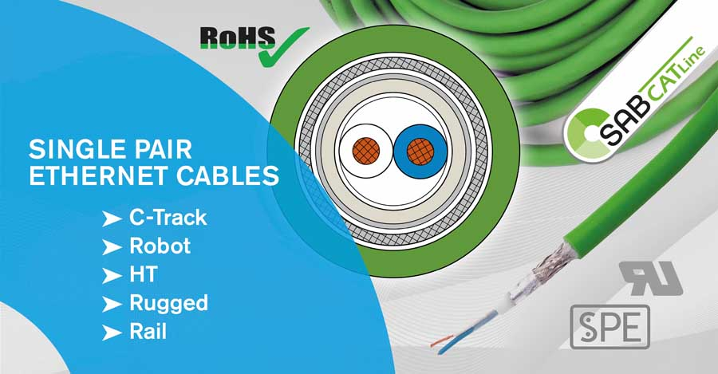
Caption: Special cable manufacturer SAB Bröckskes presents five new SPE cables for automation, high-temperatures, outdoor applications and railway technology

Image/s: | sab-spe_3_2000.jpg | Characters: | 1545
File name: | 202401010_pm_spe_cables_en | Date: | 01-16-2024
About SAB Bröckskes
Founded in Viersen, Germany, in 1947 by Peter Bröckskes as a one-man operation for electrical system design, SAB Bröckskes GmbH & Co. KG has grown into one of the world’s leading special cable manufacturers, now employing a staff of more than 550 who generate a turnover of over €134 million euros in over 100 countries. The portfolio includes cables and wires manufactured from a wide variety of materials as well as cable assembly and measurement solutions. All products are developed and manufactured exclusively at the Viersen headquarters. The company supplies various industries from industrial automation and communication technology to manufacturers of construction and agricultural machinery, railway and shipping technology and medical technology. SAB Bröckskes has a global presence with international subsidiaries and sales offices.
Contact:  SAB BRÖCKSKES GmbH & Co. KG  Sacir Adrovic  Grefrather Str. 204-212b  41749 Viersen  Germany  Phone: +49 2162 898-146  Email: s.adrovic@sab-cable.com  Internet: www.sab-cable.com |  | gii die Presse-Agentur GmbH  Immanuelkirchstr. 12  10405 Berlin  Germany  Phone: +49 30 538 965-0  Email: info@gii.de  Internet: www.gii.de

