Press Release

RAFI joins United Nations Global Compact

As part of its corporate strategy to achieve sustainable, resource-saving and climate-friendly growth, RAFI GmbH & Co. KG has joined the UN Global Compact. This participation by the German parent company is a further step in the alignment of its corporate development with the UN Sustainable Development Goals for safeguarding human rights, promoting fair labor conditions, protecting the environment, and eliminating corruption. By joining the German network, RAFI has committed to complying with these UN criteria and transparently documenting and publishing its progress in annual reports. “Having signed the UN Global Compact, we can leverage the contacts and experience of the network to implement our sustainability goals even more efficiently,” explains Dr. Lothar Seybold, RAFI’s CEO. This move underlines the commitment of the globally operating supplier of solutions for control systems and human-machine interaction to corporate development in line with ecological and social values. Its current sustainability projects include the expansion of renewable energy generation via photovoltaic and cogeneration systems as well as a modernization drive that will improve the energy efficiency of its German plants. The buildings are successively being fitted with new, eco-friendly roofs, facades, and glazing. Furthermore, RAFI is highly invested in vocational and further training, contributes to regional charities, and supports social commitment of its employees. The company has won several awards for its activities in sustainability and social responsibility, and in 2023 received the EcoVadis medal in Silver.

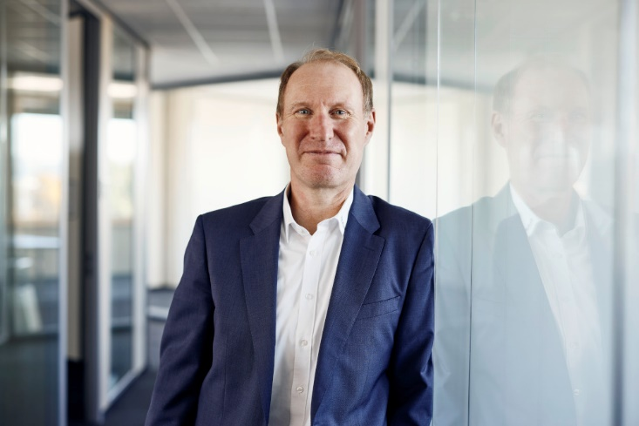

Caption: Dr. Lothar Seybold, CEO of RAFI: “Our participation in the UN Global Compact helps us to implement our sustainability goals even more efficiently.”

Image/s: | Lothar Seybold_2000.jpg | Characters: | 1,623
File name: | 202402010_pm_global-compact.docx | Date: | 03-06-2024

About the RAFI group
Founded in 1900, RAFI today develops and produces electromechanical components and systems for human-machine interaction. The range of products includes key switches, switches, touchscreens, control systems and electronic assemblies. RAFI products are employed in many industries including automation, medical technology, machine and plant engineering, road and railway vehicles, household appliances and telecommunication. The RAFI group operates internationally with more than 2,000 employees at sites in Germany, Europe, China, and the USA. Its headquarters are in Berg, Germany.

Contact:  RAFI GmbH & Co. KG  Tatjana Schweitzer  Ravensburger Str. 128–134  88276 Berg, Germany  Phone: +49 751 89-1468  Email: tatjana.schweitzer@rafi-group.com  Web: www.rafi-group.com |  | gii die Presse-Agentur GmbH  Immanuelkirchstr. 12  10405 Berlin, Germany  Phone: +49 30 53 89 65-0  Email: info@gii.de  Web: www.gii.de

