Press Release

Versatile LOXrail solutions at LogiMAT trade fair

At the LogiMAT exhibition from 19 to 21 March, in Stuttgart, Germany, LOSYCO (booth 7/A51) will present a selection of its diverse LOXrail-based solutions for heavy-duty transport in production, loading and material logistics. The German manufacturer will showcase customer-specific application examples and innovative system components. The LOXrail technology allows for easy, energy-saving and cost-efficient transportation of loads weighing several tons. The company implements LOXrail layouts in various expansion stages and with different degrees of automation to optimally meet the requirements of diverse applications from heavy-duty transport in mechanical and plant engineering to precision feeding welding cells and laser cutting systems. In addition, the LOXrail system is suitable for transporting heavy loads in warehousing. Multiple expansion options from lifting and lowering platforms to heavy-duty weigh stations allow for flexible adaptions to specific production requirements. Branching assembly lines can be realized with crossings and turntables for an unhindered production flow and easy re-routing of semi-finished products. Drive systems can optionally be installed under the floor, with inductive power supply and sensor-based position detection. The LOSYCO team is looking forward to welcoming visitors to the booth and discussing their intra-logistics requirements and customized solutions.

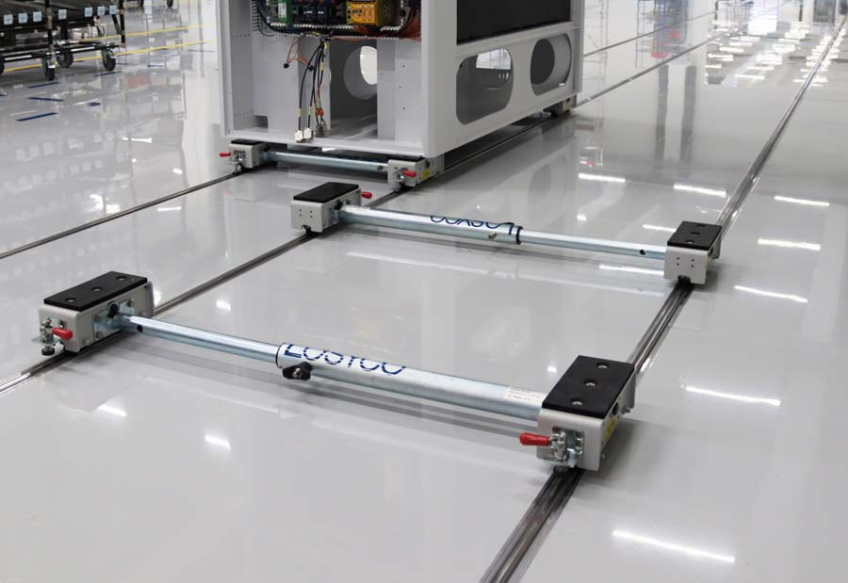
Caption 1: Assembly line for wire bonders: variable conveyor concept with customer-specific transport trolleys for different track spacing

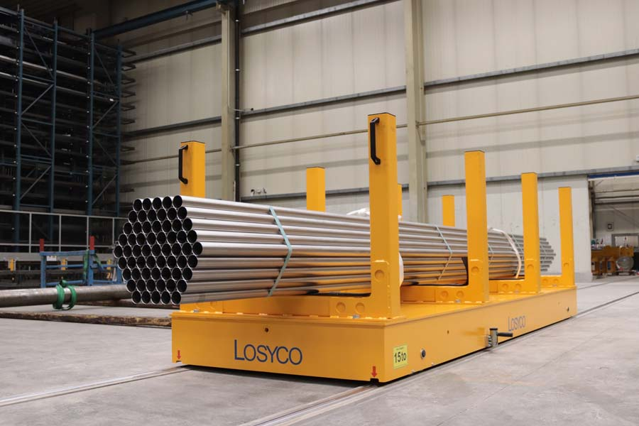
Caption 2: In addition to its use in assembly lines and loading systems, the LOXrail system is also ideal for material transport in warehouse logistics

Image/s: | radsatz-teleskopachse_2000px.jpg  transport-rohrgebinde_2000.jpg | Characters: | 1417
File name: | 202402017_pm_logimat_en | Date: | 02-14-2024
About Losyco
LOSYCO designs, builds, and installs intra-logistics systems for the manufacturing industry. The company based in Bielefeld, Germany, was founded by experienced engineers in 2016. LOSYCO’s core product is the LOXrail® floor rail system for easy transport and precise positioning of loads weighing several tons. LOXrail transport platforms can be operated manually or with auxiliary drives. LOSYCO also supplies handling equipment such as chain and roller conveyors, material management and storage systems, as well as sound-proof cabins and machine covers. LOSYCO supports customers wishing to transform their production processes to lean manufacturing and continuous flow production. LOSYCO is a member of the DRECKSHAGE Family.
Contact:  LOSYCO GmbH  Member of the DRECKSHAGE Family  Manuel Granz  Walter-Werning-Str. 7  33699 Bielefeld  Germany  Tel.: +49 . 521 . 945 643-0  Email: info@losyco.com  Internet: www.losyco.com |  | gii die Presse-Agentur GmbH  Immanuelkirchstr. 12  10405 Berlin  Germany  Tel.: +49 . 30 . 538 965-0  Email: info@gii.de  Internet: www.gii.de

