Press Release

Elephant enclosures for large cameras up to 100 mm x 100 mm

autoVimation expands its product range, adding protective enclosures for cameras with cross-sections up to 100 mm x 100 mm and lens diameters up to 120 mm, as well as for board-level embedded vision systems with up to 120 mm wide PCBs. Protecting larger cameras than any previous autoVimation enclosures, the new Elephant is the worthy successor of the Mammoth, which became extinct last year. The German manufacturer’s patented Quick-Lock/Heat-Guide camera mount provides secure attachment and excellent heat dissipation. The rugged IP67 enclosures with 40-mm dovetail profiles are available in three standard lengths that accommodate up to 250 mm long camera installations. Tailored enclosures up to 1 m long and longer are realized on request. The Elephant enclosures have a default 4″ BK7 window with an 88 mm aperture. A 3″ flange top adapts the enclosures for the use of any Orca fronts or extensions, thus also enabling mounting of the powerful Meganova LED ring light as well as various special windows for thermography applications or fisheye lenses. The enclosures are compatible with the manufacturer’s brackets, mounting kits and extensive range of accessories, including temperature control solutions. Shortly, the series will be supplemented by two special enclosures with Peltier and water cooling.
More information: https://www.autovimation.com/en/enclosures-en/elefant

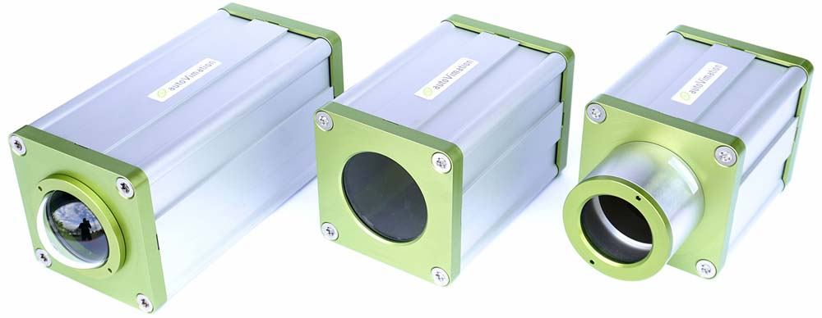
Caption: The new Elephant enclosures for larger cameras are available in three lengths, with enclosure extensions, temperature control and various special windows

Image/s: | elephant_camera_enclosures | Characters: | 1313
File name: | 202402027_pm_elephant_cam_enclosure_en | Date: | 03-12-2024
About autoVimation
Founded in 2008, autoVimation is a pioneer in the design and production of industrial-grade protective camera enclosures and a complete building kit for the simple, cost- and time-saving installation of image processing components. Vision system integrators, OEMs, plant manufacturers and operators worldwide find the German manufacturer a trusted source for enclosures in various sizes as well as a huge modular range of dovetail profiles, clamps and angles for flexible positioning and adjustment of cameras, lasers and other components above production lines and in all kinds of industrial and other settings. Once aligned, all connectors ensure permanently stable fixation with up to 2000 N displacement force and 90 Nm torsion resistance. The patented Quick-Lock/Heat-Guide camera mount provides excellent heat dissipation and enables flexible camera positioning inside the protective enclosure. autoVimation’s powerful LED ring lighting with a flash controller also stays cool thanks to good heat coupling to the outer enclosure and, mounted directly behind the window, is protected according to IP67. An extensive range of accessories enables camera technology to be used under challenging conditions: protective flaps and wind curtains for particularly dirty installation environments and temperature control solutions for ambient temperatures from -40 °C to 250 °C. A complete hygienic modular building kit in accordance with strict EHEDG specifications enables the legally compliant installation of image processing components in food or pharmaceutical processes.
Contact:  autoVimation GmbH  Peter Neuhaus  Roemerweg 1  76287 Rheinstetten  Germany  Phone: +49 . 721 . 627 6756  Email: sales@autovimation.com  Internet: www.autovimation.com |  | gii die Presse-Agentur GmbH  Immanuelkirchstr. 12  10405 Berlin  Germany  Phone: +49 . 30 . 538 9650  Email: info@gii.de  Internet: www.gii.de

