Press Release

2 in 1: Diagnostics Tester and Test Adapter for AC Charging Points

Launching PROFITEST H+E EXPERT CHECK, Gossen Metrawatt introduces a robust diagnostic tester corresponding to measurement category CAT III 300 V for standard-compliant functional testing of AC charging stations in accordance with DIN EN/IEC 61851-1 (VDE 0122-1). The handheld tester enables electricians to quickly and reliably test the functionality, electrical safety and personal protection of 1- and 3-phase AC charging points in charging mode 3 on a type 2 socket or a permanently connected type 2 cable. As a unique selling proposition in this product class, the device provides standard-compliant testing of PE interruptions with graphical display of measured values. The functional range includes the verification of vehicle states A, B, C and D; phase tests and phase sequence tests; diode testing; evaluation of the PWM signal for data communication and abortion of the charging process during short-circuit simulation as well as determination of battery charging levels. In combination with installation testers from the PROFITEST MF or PROFITEST MASTER IQ series, the device can also be used as a test adapter for electrical testing of the charging infrastructure thanks to its measuring inputs and earthing contact socket. In addition to the charging function tests, all relevant safety tests can also be carried out in this combination, including, for example, low-impedance continuity of the conductors, insulation resistance, tripping of the residual current circuit breaker (RCD/FI), 6-mA sensors and loop and internal mains resistance. Measured values and test results are shown in plain text on the device display.

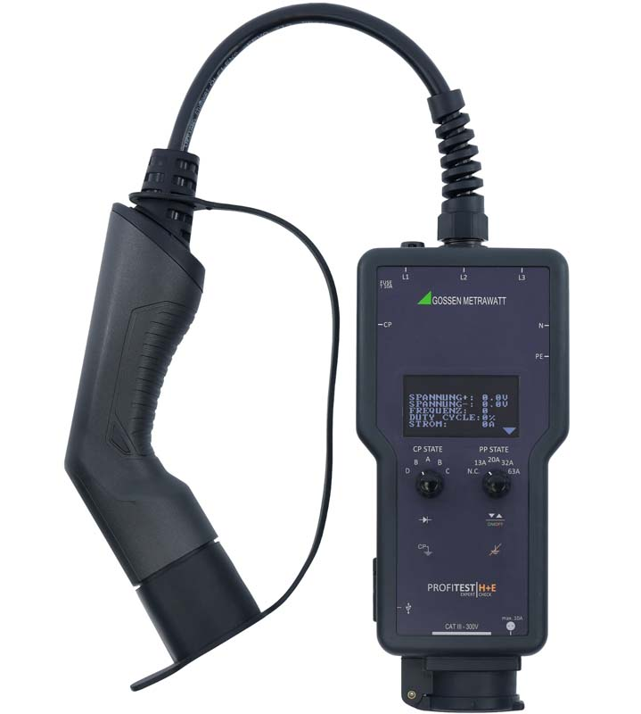
Caption: Two in one: the compact handheld PROFITEST H+E EXPERT CHECK for AC charging points can be used as a diagnostic tester and test adapter

Image/s: | pt_he_expertcheck_2000.jpg | Characters: | 1633
File name: | 202403009_pm_expert_emo_checck_en | Date: | 04-10-2024
About Gossen Metrawatt
Gossen Metrawatt, one of the world’s leading suppliers of measurement systems, develops and distributes a wide range of high-quality measuring and test devices for electrical trade, various industries and the public sector.
The Gossen Metrawatt brand has been synonymous with safety and quality “Made in Germany” for decades. Its product range includes measurement and test technology for the electrical safety of plants, devices and machines as well as for the e-mobility and medical technology industries. Additional key areas of interest are power quality, battery testing technology, multimeters, calibrators, power supply technology and energy management systems. For a truly comprehensive electrical safety portfolio, Gossen Metrawatt also offers a continuously growing range of digital services and cloud services and supports its customers with a versatile training program and a wide range of after-sales services.
Gossen Metrawatt is part of the GMC Instruments Group, which also includes other specialized manufacturers for measurement and testing technology – notably, Camille Bauer Metrawatt, Dranetz, Prosys, Seaward and Rigel and Kurth Electronic. The Camille Bauer and Rigel brands add to the portfolio various transducers, display instruments and detection systems for heavy-current engineering as well as special measuring, testing and functional testing devices for the medical sector. The GMC-I Group runs its own DAkkS-certified calibration center that performs DAkkS, ISO and factory calibrations for virtually all electrical measured quantities. The GMC-I Group has development and production sites in Germany, Switzerland, England and the USA and a worldwide sales network of its own companies as well as sales partners.
Contact:  Gossen Metrawatt GmbH  Christian Widder  Head of Marketing Communication  Suedwestpark 15  90449 Nuremberg  Germany  Phone: +49 . 911 . 8602-572  Email: christian.widder@gossenmetrawatt.com  Internet: www.gossenmetrawatt.com |  | gii die Presse-Agentur GmbH  Christburger Str. 41  10405 Berlin  Germany  Tel.: +49 . 30 . 538 9650  Email: info@gii.de  Internet: www.gii.de

