Press Release

Simply multifunctional:
New METRALINE MF installation tester

The measurement and testing technology specialist Gossen Metrawatt expands its cost-effective, user-friendly METRALINE series, adding a new multifunctional installation tester. METRALINE MF, certified for CAT III 600 V / CAT IV 300 V, enables all required tests in electrical systems and installations in accordance with the current DIN VDE 0100-600 and DIN VDE 0105-100 standards. The portable, battery-powered tester features a graphic color display and easy menu navigation for intuitive operation and convenient operation. Support functions such as help images and audio signals help to carry out the measurement tasks. The comprehensive test spectrum includes low-resistance measurement with 200 mA and automatic polarity reversal, loop and mains impedance measurement with RCD, 3- and 4-pole earthing measurements, insulation measurements up to 1000 V and RMS voltage measurement. In addition, all measurements of commercially available RCDs and RDC-DDs with 6 mA DC for electric charging points can be performed. Up to 1000 measurement data can be stored in the large instrument memory and made available in just a few steps with the integrated METRAreport software for generating test reports. Regular firmware updates keep the installation tester up to date. Gossen Metrawatt supplies the new METRALINE MF complete with carrying case, power supply unit and rechargeable batteries. The extensive range of accessories includes three 1-m measurement cables, three test probes and alligator clips each, as well as one measurement cable, each with earthing contact plug or test button.

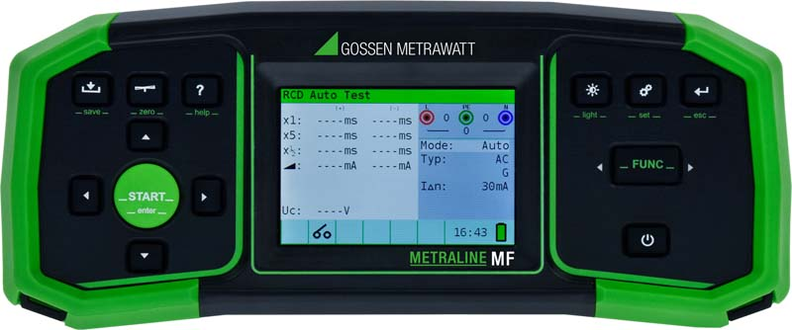
Caption: The new, cost-effective METRALINE MF installation tester combines a wide range of functions with simple operation and intuitive menu navigation

Image/s: | Metraline_MF_front_2000.jpg |  | Characters: | 1589
File name: | 202403010_pm_metraline_mf_installation_tester_en |  | Date: | 03-12-2024
About Gossen Metrawatt
Gossen Metrawatt, one of the world’s leading suppliers of measurement systems, develops and distributes a wide range of high-quality measuring and test devices for electrical trade, various industries and the public sector.
The Gossen Metrawatt brand has been synonymous with safety and quality “Made in Germany” for decades. Its product range includes measurement and test technology for the electrical safety of plants, devices and machines as well as for the e-mobility and medical technology industries. Additional key areas of interest are power quality, battery testing technology, multimeters, calibrators, power supply technology and energy management systems. For a truly comprehensive electrical safety portfolio, Gossen Metrawatt also offers a continuously growing range of digital services and cloud services and supports its customers with a versatile training program and a wide range of after-sales services.
Gossen Metrawatt is part of the GMC Instruments Group, which also includes other specialized manufacturers for measurement and testing technology – notably, Camille Bauer Metrawatt, Dranetz, Prosys, Seaward and Rigel and Kurth Electronic. The Camille Bauer and Rigel brands add to the portfolio various transducers, display instruments and detection systems for heavy-current engineering as well as special measuring, testing and functional testing devices for the medical sector. The GMC-I Group runs its own DAkkS-certified calibration center that performs DAkkS, ISO and factory calibrations for virtually all electrical measured quantities. The GMC-I Group has development and production sites in Germany, Switzerland, England and the USA and a worldwide sales network of its own companies as well as sales partners.
Contact:  Gossen Metrawatt GmbH  Christian Widder  Head of Marketing Communication  Suedwestpark 15  90449 Nuremberg  Germany  Phone: +49 . 911 . 8602-572  Email: christian.widder@gossenmetrawatt.com  Internet: www.gossenmetrawatt.com |  | gii die Presse-Agentur GmbH  Immanuelkirchstr. 12  10405 Berlin  Germany  Tel.: +49 . 30 . 538 9650  Email: info@gii.de  Internet: www.gii.de

