Press Release

New LOXrail turntables for construction machinery production

LOSYCO has implemented new assembly lines for excavator and wheel loaders in the German plant of YANMAR CE, one of the world’s leading construction machinery manufacturers. The LOXrail transport system features floor-level rails with a 25-mm shaft diameter for payloads up to 20 tons. The plant layout with three corners posed a particular challenge. Previously installed rails required extra effort, in that the loaded trolleys had to be coupled to a special towing device in order to navigate any of the curves. To improve upon this, LOSYCO installed three motorized, sensor-controlled turntables, which interface directly with the rails and allow smooth maneuvering around corners. As another innovation, LOSYCO introduced separate lines for the excavator undercarriages and superstructures, which significantly facilitates handling. A newly installed rail-guided transverse shuttle allows staff to manually unite both modules for final assembly. Lifting platforms integrated into the route with sensor-controlled end position detection ensure safe and precise transition when the construction machines are lifted from the rails at the end of the assembly line in order to mount the wheels. “A major advantage of the new rail system is its low friction. Therefore, the machines can be easily pushed from one station to the next by hand. Built-in maneuvering elements such as turntables and the shuttle ensure efficient, safe work processes and reduce the physical strain on our employees,” says YANMAR plant manager Stefan Rückartt.

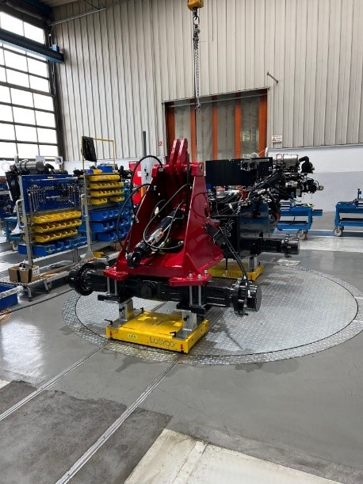
Caption: LOSYCO has realized new construction machinery assembly lines with motorized turntables (image: YANMAR CE)

Image/s: | radlader-drehscheibe_2000.jpg | Characters: | 1535
File name: | 202404008_pm_yanmar_loxrail_turntables_en | Date: | 04-17-2024
About Losyco
LOSYCO designs, builds, and installs intra-logistics systems for the manufacturing industry. The company based in Bielefeld, Germany, was founded by experienced engineers in 2016. LOSYCO’s core product is the LOXrail® floor rail system for easy transport and precise positioning of loads weighing several tons. LOXrail transport platforms can be operated manually or with auxiliary drives. LOSYCO also supplies handling equipment such as chain and roller conveyors, material management and storage systems, as well as sound-proof cabins and machine covers. LOSYCO supports customers wishing to transform their production processes to lean manufacturing and continuous flow production. LOSYCO is a member of the DRECKSHAGE Family.
Contact:  LOSYCO GmbH  Member of the DRECKSHAGE Family  Tim Schneider  Walter-Werning-Str. 7  33699 Bielefeld  Germany  Tel.: +49 . 521 . 945 643-0  Email: info@losyco.com  Internet: www.losyco.com |  | gii die Presse-Agentur GmbH  Christburger Str. 41  10405 Berlin  Germany  Tel.: +49 . 30 . 538 965-0  Email: info@gii.de  Internet: www.gii.de

