Press Release

Twice as tight cable outlet for protective enclosures

autoVimation presents an additional cable routing option for protective camera enclosures in demanding environments. The new RWA+C adapter combines the existing rear wall options RWA featuring an IP69k cable conduit and RWC featuring an IP68 cable gland. The adapter sleeve replaces the cable gland’s compression fitting and tightly packs its large sealing insert, also reliably sealing multiple cables. The M32 thread at the upper end of the sleeve allows the attachment of corrugated plastic or metal conduits, which are supplied in specified lengths. The sleeve adapter made of V4A stainless steel is suitable even for under-water use. The hose option also protects cables from UV light, aggressive cleaning agents, and chlorine. Ongoing practical applications include swimming pools and production areas with corrosive atmospheres. The optionally available metal conduit with a thick PVC coating has been successfully tested according to IP68 under water pressure at 15 bar. autoVimation’s food-approved hygienic hoses can also be used with the RWA+C adapter. This allows users to safely route any cables in sensitive food applications without the need for separate certifications. Since the new adapter sleeve fits all M32 cable glands with a standard sealing insert and M25 glands with an extended sealing insert, it can be used with almost any of autoVimation’s protective camera enclosures.

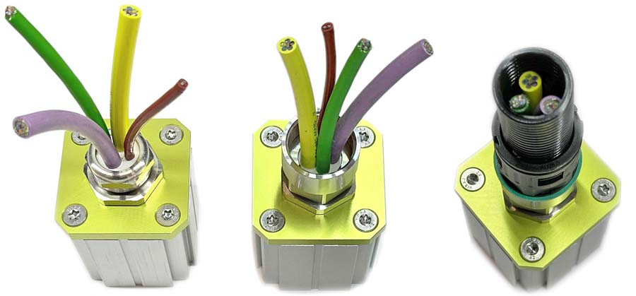
Caption: The RWA+C adapter combining cable gland and conduit connector enables protected cable routing in vision applications in demanding environments

Image/s: | rear_wall_rwac | Characters: | 1398
File name: | 202404010_pm_tight_cable_outlet_rwac_en | Date: | 04-29-2024
About autoVimation
Founded in 2008, autoVimation is a pioneer in the design and production of industrial-grade protective camera enclosures and a complete building kit for the simple, cost- and time-saving installation of image processing components. Vision system integrators, OEMs, plant manufacturers and operators worldwide find the German manufacturer a trusted source for enclosures in various sizes as well as a huge modular range of dovetail profiles, clamps and angles for flexible positioning and adjustment of cameras, lasers and other components above production lines and in all kinds of industrial and other settings. Once aligned, all connectors ensure permanently stable fixation with up to 2000 N displacement force and 90 Nm torsion resistance. The patented Quick-Lock/Heat-Guide camera mount provides excellent heat dissipation and enables flexible camera positioning inside the protective enclosure. autoVimation’s powerful LED ring lighting with a flash controller also stays cool thanks to good heat coupling to the outer enclosure and, mounted directly behind the window, is protected according to IP67. An extensive range of accessories enables camera technology to be used under challenging conditions: protective flaps and wind curtains for particularly dirty installation environments and temperature control solutions for ambient temperatures from -40 °C to 250 °C. A complete hygienic modular building kit in accordance with strict EHEDG specifications enables the legally compliant installation of image processing components in food or pharmaceutical processes.
Contact:  autoVimation GmbH  Peter Neuhaus  Roemerweg 1  76287 Rheinstetten  Germany  Phone: +49 . 721 . 627 6756  Email: sales@autovimation.com  Internet: www.autovimation.com |  | gii die Presse-Agentur GmbH  Christburger Str. 12  10405 Berlin  Germany  Phone: +49 . 30 . 538 9650  Email: info@gii.de  Internet: www.gii.de

