Press Release

Protective temperature-controlled enclosures for cameras up to 100 mm x 100 mm

autoVimation now offers protective enclosures with Peltier temperature control for cameras with cross-sections up to 100 mm x 100 mm and maximum lens diameters of 120 mm. The highly efficient and space-saving Turtle enclosures cool the built-in camera technology to up to 30 °K below ambient temperature. They enable machine vision applications at ambient temperatures from -20 °C to 70 °C and thus in almost all climate zones and in warm industrial applications where water cooling installation is not possible or would be too complex. The previous models have been tried and tested in active service in the hottest desert areas worldwide for 12 years.

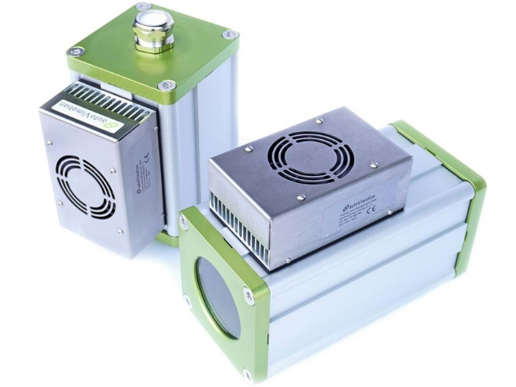
Caption: The protective enclosures with a Peltier element provide automatic and autonomous temperature control for cameras at ambient temperatures from -20 °C to 70 °C

Three control options are available: a compact internal controller only for cooling; a two-point external controller with automatic switching between heating and cooling; and exact thermal control, which keeps the camera at a specified temperature – especially for measurement applications that require top precision. The UV and weather-resistant enclosures ensure reliable IP65 protection. The low-energy 24-V power supply can be realized with solar cells for autonomous operation in remote installations. The standard enclosures have internal lengths of 180 mm and 250 mm respectively. They are supplied with a front cover with a large 4″ BK7 window, with an aperture diameter of 88 mm, suitable for large lenses. The alternatively available flange lid allows the combination of the Turtle Elephant with all Orca extensions and front lids, such as 3″ dome windows for fisheye lenses, germanium windows for thermal imaging applications or the Meganova LED ring light from autoVimation. Furthermore, there is an extensive range of brackets and mounting kits for enclosure mounting.
Product page: https://www.autovimation.com/en/enclosures-en/turtle-en

Image/s: | turtle_elephant | Characters: | 1734
File name: | 202404011_pm_turtle_cooling_enclosures_en | Date: | 04-10-2024
About autoVimation
Founded in 2008, autoVimation is a pioneer in the design and production of industrial-grade protective camera enclosures and a complete building kit for the simple, cost- and time-saving installation of image processing components. Vision system integrators, OEMs, plant manufacturers and operators worldwide find the German manufacturer a trusted source for enclosures in various sizes as well as a huge modular range of dovetail profiles, clamps and angles for flexible positioning and adjustment of cameras, lasers and other components above production lines and in all kinds of industrial and other settings. Once aligned, all connectors ensure permanently stable fixation with up to 2000 N displacement force and 90 Nm torsion resistance. The patented Quick-Lock/Heat-Guide camera mount provides excellent heat dissipation and enables flexible camera positioning inside the protective enclosure. autoVimation’s powerful LED ring lighting with a flash controller also stays cool thanks to good heat coupling to the outer enclosure and, mounted directly behind the window, is protected according to IP67. An extensive range of accessories enables camera technology to be used under challenging conditions: protective flaps and wind curtains for particularly dirty installation environments and temperature control solutions for ambient temperatures from -40 °C to 250 °C. A complete hygienic modular building kit in accordance with strict EHEDG specifications enables the legally compliant installation of image processing components in food or pharmaceutical processes.
Contact:  autoVimation GmbH  Peter Neuhaus  Roemerweg 1  76287 Rheinstetten  Germany  Phone: +49 . 721 . 627 6756  Email: sales@autovimation.com  Internet: www.autovimation.com |  | gii die Presse-Agentur GmbH  Christburger Str. 12  10405 Berlin  Germany  Phone: +49 . 30 . 538 9650  Email: info@gii.de  Internet: www.gii.de

