Press Release

Application-specific magnetic sensors for extreme conditions

EGE-Elektronik launches MGK magnetic sensors for use in cryogenic processes in medical technology and beyond. Based on the MGK series, the sensors were specifically designed for continuous operation at low temperatures down to -80 °C. The manufacturer specialized in robust sensor technology for demanding applications offers very short response times for the application-specific adaptation of sensors featuring, for example, increased protection classes, interfaces according to customer requirements or, as here, special materials that can withstand dry cryogenic atmospheres over the long term. The MGK magnetic sensors are tripped when a magnetic contact comes near them. They are suitable, for example, for detecting, counting or positioning transport containers, flaps, doors or valve positions. The sensing distance is 5...20 mm, depending on the flux density of the magnet. The use of magnetic sensors enables increased sensing distances even at extreme temperatures and temperature profiles that challenge inductive sensors. They also detect objects through non-magnetic materials such as plastic walls.

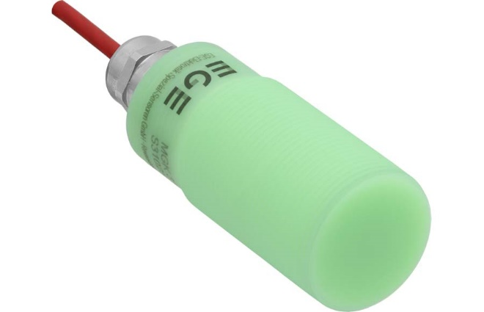
Caption: MGK-type magnetic sensors from EGE-Elektronik detect objects and monitor the opening and closing of flaps and doors in cryogenic processes down to -80 °C

Image/s: | mgk_magnetic_sensor | Characters: | 1113
File name: | 202404019_pm_mgk_magnetic_sensors_en | Date: | 05-21-2024
About EGE
EGE-Elektronik Spezial-Sensoren GmbH has been developing and manufacturing special purpose sensors for automation applications since 1976. The company serves leading international producers from a wide range of industries. Its product portfolio includes flow controllers, infrared, opto and ultrasonic sensors, capacitive proximity switches, light barriers and inductive proximity switches. EGE also provides sensors for highly sensitive applications, e.g. hazardous areas. The development department's highly qualified staff cooperates closely with all customers, ensuring continuous product updates and enhancement. A total of 130 employees, including 20 engineers and technicians, generate gross sales of approx. 19.5 million Euros worldwide.
Contact:  EGE-Elektronik Spezial-Sensoren GmbH  Sven-Eric Hiss  Ravensberg 34  24214 Gettorf  Germany  Phone: +49 . 4346 . 4158-0  Email: info@ege-elektronik.com  Internet: www.ege-elektronik.com |  | gii die Presse-Agentur GmbH  Immanuelkirchstr. 12  10405 Berlin  Germany  Phone: +49 . 30 . 538 9650  Email: info@gii.de  Internet: www.gii.de

