Press Release

Flow meter with IO-Link

EGE-Elektronik has launched a new flow measurement system with a separate evaluation unit and an IO-Link interface. The ST 55 S sensor detects flow velocities from 0.05 m/s to 3 m/s and temperatures from 0 °C to 80 °C in liquid media. The 47 mm, 80 mm or 120 mm long probe is installed in pipelines with internal diameters from 15 mm to 250 mm. Optimally matched to the probe, the SNA 552 GAPL evaluation electronics calculates the flow rate, displays it in l/min or m³/h and can transmit it to a PLC via IO-Link. The easy-to-read display can be tilted and turned upside down. Users can conveniently parameterize the measuring points via buttons on the housing or via IO-Link. The stainless-steel electronics unit features IP65 protection and is suitable for ambient temperatures from -10°C to 60°C. It is connected to the sensor via an up to 5 m long cable with an M12 plug. In addition to IO-Link, the evaluation electronics unit features independently configurable switching outputs or a current output. Functions such as min/max/average memory as well as fault monitoring and access level management are integrated directly into the device. Special operating modes such as hysteresis or dosing ensure optimal function in various applications. The manufacturer also offers the right accessories for mounting and integration into IO-Link networks.

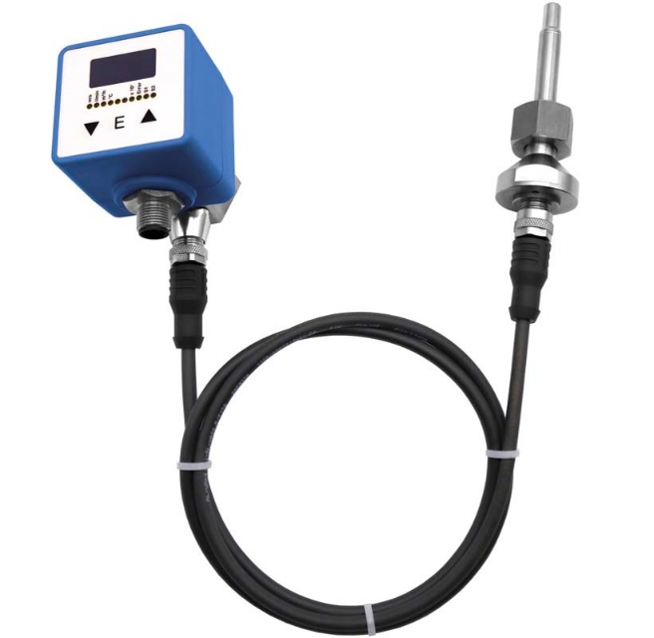
Caption: The new evaluation electronics and sensor for flow measurement in liquid media can be configured and checked directly in the field and via IO-Link

Image/s: | flow_meter_st_55_s__sna_552_gapl_f1832 | Characters: | 1349
File name: | 202404020_pm_flow_meter_io-link_en | Date: | 04-22-2024
About EGE
EGE-Elektronik Spezial-Sensoren GmbH has been developing and manufacturing special purpose sensors for automation applications since 1976. The company serves leading international producers from a wide range of industries. Its product portfolio includes flow controllers, infrared, opto and ultrasonic sensors, capacitive proximity switches, light barriers and inductive proximity switches. EGE also provides sensors for highly sensitive applications, e.g. hazardous areas. The development department's highly qualified staff cooperates closely with all customers, ensuring continuous product updates and enhancement. A total of 130 employees, including 20 engineers and technicians, generate gross sales of approx. 19.5 million Euros worldwide.
Contact:  EGE-Elektronik Spezial-Sensoren GmbH  Sven-Eric Hiss  Ravensberg 34  24214 Gettorf  Germany  Phone: +49 4346 4158-0  Email: info@ege-elektronik.com  Internet: www.ege-elektronik.com |  | gii die Presse-Agentur GmbH  Christburger Str. 41  10405 Berlin  Germany  Phone: +49 30 538 965-0  Email: info@gii.de  Internet: www.gii.de

