Press Release

Flexible LOXrail AllRounder trolley turns corners

LOSYCO, a specialist in intra-logistics and material feeding, has introduced a new, innovative solution for rail-based transport, extending its LOXrail program. The new AllRounder generation is the first ever solution for going around corners and making 180° about-turns on the floor-level conveyor rails that does not require the installation of additional maneuvering elements in the floor, such as turntables or intersections. For this purpose, the battery-powered transport trolleys have a special chassis. The AllRounder transport system enables particularly flexible lines even in factories with complex floor plans. Support pillars and other obstacles can be circumnavigated with little installation effort. In addition, the new solution is suited for automatically returning the trolleys from the end of the line back to the start without additional conveyor equipment. The new AllRounder model is designed for payloads up to 10 tons, running on the LOXrail 25. LOSYCO will adapt it to customer requirements in terms of dimensions and track widths.

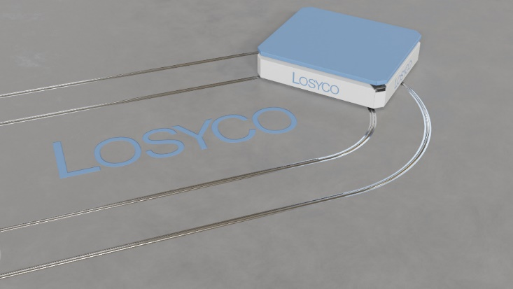
Caption: The AllRounder can transport goods weighing up to 10 tons around curves and hairpin bends in LOXrail lines without any shunting

Image/s: | kurvenallrounder2_2000px.jpg | Characters: | 1056
File name: | 202404025_pm_allrounder_en | Date: | 06-05-2024
About Losyco
LOSYCO designs, builds, and installs intra-logistics systems for the manufacturing industry. The company based in Bielefeld, Germany, was founded by experienced engineers in 2016. LOSYCO’s core product is the LOXrail® floor rail system for easy transport and precise positioning of loads weighing several tons. LOXrail transport platforms can be operated manually or with auxiliary drives. LOSYCO also supplies handling equipment such as chain and roller conveyors, material management and storage systems, as well as sound-proof cabins and machine covers. LOSYCO supports customers wishing to transform their production processes to lean manufacturing and continuous flow production. LOSYCO is a member of the DRECKSHAGE Family.
Contact:  LOSYCO GmbH  Member of the DRECKSHAGE Family  Manuel Granz  Walter-Werning-Str. 7  33699 Bielefeld  Germany  Tel.: +49 . 521 . 945 643-0  Email: info@losyco.com  Internet: www.losyco.com |  | gii die Presse-Agentur GmbH  Immanuelkirchstr. 12  10405 Berlin  Germany  Tel.: +49 . 30 . 538 965-0  Email: info@gii.de  Internet: www.gii.de

