Press Release

Menzel opens new headquarters and motor plant

Menzel Elektromotoren has celebrated the opening of its new headquarters near Berlin with a grand inauguration party. In honor of company founder Kurt Menzel, the date was set for his 120th birthday on 14 May 2024. The German manufacturer successfully markets its industrial motors and tailor-made drive systems worldwide, with increasing numbers year on year. This continued success now required more space and modern production facilities designed for efficient processes and larger, heavier machines. In addition to state-of-the-art machinery, efficient paint shops and test fields that can accommodate even the largest motor configurations, the new plant is prepared for further growth. In coming years, the workforce at this site can be expanded from around 100 to 150, allowing the manufacturer to meet all customer requests.

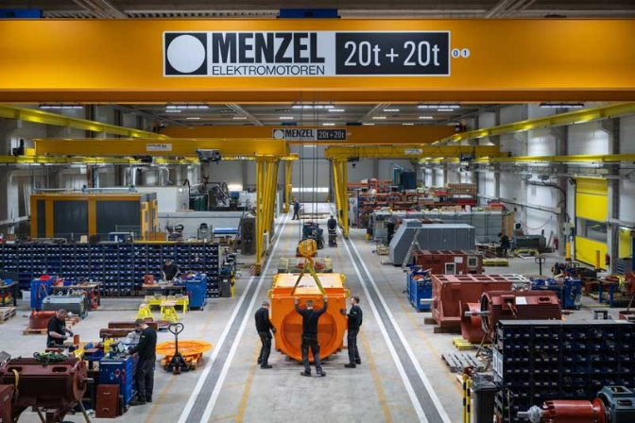
Caption: Menzel Elektromotoren has found a suitable location for a new factory building with state-of-the-art equipment in Hennigsdorf, just outside Berlin

Menzel manufactures its own motor series and also specializes in custom models and exact replicas of existing machines. Menzel builds new motors with outputs up to and beyond 25 MW from scratch, stocks a large range of motor variants up to 15 MW and adapts them at short notice for various drive tasks. The company also offers testing of motors, generators and rotary converter sets. Since the official factory commissioning on 2 January 2024, the quality management system has already been certified according to DIN EN ISO 9001:2015.
More information: https://www.menzel-motors.com/article/moving-to-new-motor-plant/

Dates and figures on the construction of the new plant:
- Foundation stone laying: 11 June 2022 at > 30 °C
- Topping out ceremony: 16 December 2022 at -10 °C
- Construction period: 17 months, completion on schedule
- Official commissioning: 02 January 2024

- Hall floor space: 6416 m²
- Office floor space: 2096 m²
- Plot size: 22928 m²
- Earmarked expansion area: ~ 4000 m²

- Modules and material:
  - 96 windows
  - ~ 300 steel sandwich panels
  - ~ 36 km low voltage cables
  - ~ 24 km communication lines
  - ~ 1,3 km building management system cables
  - ~ 500 sockets
  - ~ 600 data ports
  - ~ 500 lighting, inside and outside

- Staff at headquarters:
  - Currently almost 100 employees from over 20 nations with a combined 933 years of work experience at MENZEL
  - Capacity for 150 employees

- Relocation cargo:
  - ~ 300 truckloads
  - ~ 2000 moving boxes

- Broken tethers: ~ 10000

- Satisfaction barometer from handover to today, 5 months after commissioning (mean value): 100 %

Image/s: | menzel_factory_floor_hennigsdorf | Characters: | 1366
File name: | 202405008_pm_motor_plant_opening_en | Date: | 05-15-2024
About Menzel Elektromotoren
Menzel Elektromotoren GmbH has been manufacturing and distributing electric motors since 1927. The German family-run company based in Hennigsdorf near Berlin specializes in the delivery of large electric motors, including special models, within the shortest time possible. The product range comprises high and low voltage motors, DC motors, transformers, and frequency inverters. Services include motor production up to and beyond 25 MW and short-term adaptation of stock motors to application-specific requirements. In order to ensure short delivery times, Menzel maintains a large inventory with over 20,000 motors up to 15 MW. Qualified engineering, experienced staff, and state-of-the-art production and testing facilities help the manufacturer provide excellent reliability. Menzel operates subsidiaries in the UK, France, Italy, Spain, and Sweden, and cooperates with numerous partners worldwide.
Contact:  Menzel Elektromotoren GmbH  Mathis Menzel  Am Alten Walzwerk 2  16761 Hennigsdorf  Germany  Phone: +49 30 349 922-0  Email: info@menzel-motors.com  Internet: www.menzel-motors.com |  | gii die Presse-Agentur GmbH  Christburger Str. 41  10405 Berlin  Germany  Phone: +49 30 538 965-0  Email: info@gii.de  Internet: www.gii.de

