Press Release

High-precision low-resistance measuring instrument with 4-wire measurement

Launching METRAOHM 10, Gossen Metrawatt presents a new low-resistance measuring instrument for the standards-compliant testing of protective conductors and equipotential bonding conductors in accordance with DIN VDE 0413-4. The ohmmeter uses the four-wire method for high-precision resistance measurements with 10 A AC including limit value calculation according to EN 60204-1. Additional functions extend to battery-powered 2-wire measurement with 200 mA DC, contact resistance testing of lightning protection and earthing systems according to DIN 18014 and low-ohm continuity testing of machines according to EN 60204-1 (VDE 0113-1). The ohmmeter, which is certified according to measurement category CAT II 600 V, features Kelvin clips for milliohm measurement that can be adjusted by means of a balancing resistor and an integrated test function. The 3.5″ TFT color display clearly displays menus, help images and measurement results. Pushbutton arrays on both sides of the display allow for convenient and user-friendly navigation. The METRAOHM 10 allows for mains and battery-powered operation. It has a compact and rugged design with dimensions of 250 mm x 107 mm x 135 mm and featuring IP40 protection. Measurement data can be transferred from the device memory to an external computer via a USB type B port for evaluation purposes by using free-of-charge software. Gossen Metrawatt supplies the METRAOHM 10 with a wide range of accessories, various test cables, a carrying pouch and a test report.

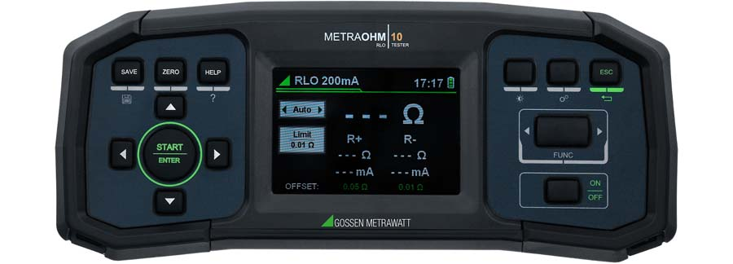
Caption: The new METRAOHM 10 from Gossen Metrawatt for high-precision resistance measurement using in the four-wire method

Image/s: | metraohm10_2000.jpg | Characters: | 1506
File name: | 202405015_pm_metraohm10_en | Date: | 05-28-2024
About Gossen Metrawatt
Gossen Metrawatt, one of the world’s leading suppliers of measurement systems, develops and distributes a wide range of high-quality measuring and test devices for electrical trade, various industries and the public sector.
The Gossen Metrawatt brand has been synonymous with safety and quality “Made in Germany” for decades. Its product range includes measurement and test technology for the electrical safety of plants, devices and machines as well as for the e-mobility and medical technology industries. Additional key areas of interest are power quality, battery testing technology, multimeters, calibrators, power supply technology and energy management systems. For a truly comprehensive electrical safety portfolio, Gossen Metrawatt also offers a continuously growing range of digital services and cloud services and supports its customers with a versatile training program and a wide range of after-sales services.
Gossen Metrawatt is part of the GMC Instruments Group, which also includes other specialized manufacturers for measurement and testing technology – notably, Camille Bauer Metrawatt, Dranetz, Prosys, Seaward and Rigel and Kurth Electronic. The Camille Bauer and Rigel brands add to the portfolio various transducers, display instruments and detection systems for heavy-current engineering as well as special measuring, testing and functional testing devices for the medical sector. The GMC-I Group runs its own DAkkS-certified calibration center that performs DAkkS, ISO and factory calibrations for virtually all electrical measured quantities. The GMC-I Group has development and production sites in Germany, Switzerland, England and the USA and a worldwide sales network of its own companies as well as sales partners.
Contact:  Gossen Metrawatt GmbH  Christian Widder  Head of Marketing Communication  Suedwestpark 15  90449 Nuremberg  Germany  Phone: +49 . 911 . 8602-572  Email: christian.widder@gossenmetrawatt.com  Internet: www.gossenmetrawatt.com |  | gii die Presse-Agentur GmbH  Immanuelkirchstr. 12  10405 Berlin  Germany  Tel.: +49 . 30 . 538 9650  Email: info@gii.de  Internet: www.gii.de

