Press Release

New all-round service for measuring and test instruments

Launching the METRACHECK service package, the GMC Instruments Group has introduced a new product to create added value for its customers. The METRACHECK package is offered by GMC-I Service GmbH, an affiliate of Gossen Metrawatt. It is available for Gossen Metrawatt test instruments from the SECUTEST ST, SECULIFE ST, PROFITEST M and PROFITEST MF series. There is a choice of four variants with terms of 24, 36, 48 or 60 months. The all-round service ensures preferential processing with short turnaround times for repair and calibration. This ensures that the instruments are ready for use again quickly and always up to date, enabling legally secure and standards-compliant test sequences. Downtimes are reduced, among other things, by the elimination of cost approval procedures, and the equipment’s service life is extended. METRACHECK can be booked directly with new devices as an add-on or purchased for existing devices, provided that the instrument was purchased within the corresponding service period. The instrument is sent to GMC-I Service GmbH with proof of purchase and the purchased service voucher. The service term starts on the date of purchase of the test instrument. The METRACHECK service includes DAkkS accredited calibrations, DGUV test certificates, repairs, firmware updates, free replacement of defective buffer batteries and battery packs as well as final testing according to manufacturer’s specifications. Returns are post-paid throughout the EU. The package includes an IZYCHECK.IQ Premium license to save device status, test certificates, documentation as well as maintenance and calibration intervals on the cloud portal and ensure their secure accessibility at any time. Detailed information about the new service offer is available at https://www.gossenmetrawatt.de/en/products/software-and-accessories/accessories/services/.

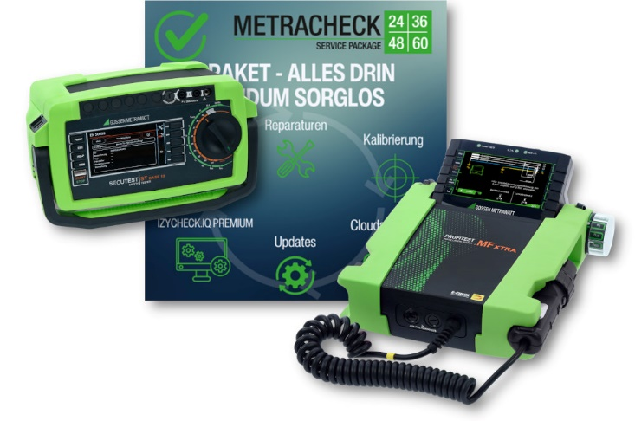
Caption: New all-round service package with variable terms for measuring and test instruments from Gossen Metrawatt

Image/s: | collage-metracheck_2000.jpg | Characters: | 1859
File name: | 202406011_pm_metracheck_en | Date: | 06-26-2024
About Gossen Metrawatt
Gossen Metrawatt, one of the world’s leading suppliers of measurement systems, develops and distributes a wide range of high-quality measuring and test devices for electrical trade, various industries and the public sector.
The Gossen Metrawatt brand has been synonymous with safety and quality “Made in Germany” for decades. Its product range includes measurement and test technology for the electrical safety of plants, devices and machines as well as for the e-mobility and medical technology industries. Additional key areas of interest are power quality, battery testing technology, multimeters, calibrators, power supply technology and energy management systems. For a truly comprehensive electrical safety portfolio, Gossen Metrawatt also offers a continuously growing range of digital services and cloud services and supports its customers with a versatile training program and a wide range of after-sales services.
Gossen Metrawatt is part of the GMC Instruments Group, which also includes other specialized manufacturers for measurement and testing technology – notably, Camille Bauer Metrawatt, Dranetz, Prosys, Seaward and Rigel and Kurth Electronic. The Camille Bauer and Rigel brands add to the portfolio various transducers, display instruments and detection systems for heavy-current engineering as well as special measuring, testing and functional testing devices for the medical sector. The GMC-I Group runs its own DAkkS-certified calibration center that performs DAkkS, ISO and factory calibrations for virtually all electrical measured quantities. The GMC-I Group has development and production sites in Germany, Switzerland, England and the USA and a worldwide sales network of its own companies as well as sales partners.
Contact:  Gossen Metrawatt GmbH  Christian Widder  Head of Marketing Communication  Suedwestpark 15  90449 Nuremberg  Germany  Phone: +49 . 911 . 8602-572  Email: christian.widder@gossenmetrawatt.com  Internet: www.gossenmetrawatt.com |  | gii die Presse-Agentur GmbH  Immanuelkirchstr. 12  10405 Berlin  Germany  Tel.: +49 . 30 . 538 9650  Email: info@gii.de  Internet: www.gii.de

