Press Release

LOXrail 40 for heavy-duty warehouse logistics

The LOXrail system from LOSYCO is available in two versions with rail diameters of 25 mm and 40 mm. In addition to being used in machine production lines and for precision loading of workpieces, the system is used for warehouse logistics and efficient handling of heavy material and components. The durable, minimal-maintenance LOXrail 40 profiles are suitable for moving goods and containers with a total weight of up to 60 tons, introducing an extremely economical heavy-duty transport method for warehouses as well as to and from loading bays. The floor-level installation does not hinder accessibility for employees and industrial trucks around and across the rail tracks. Payloads are transported on trolleys designed by LOSYCO to meet customer requirements. Low-friction wheelsets enable the trolleys to be pushed without auxiliary power. There are handles at the head of the trolleys for safe, ergonomic handling. The trolleys can be fixed in position with locking bolts in the floor to ensure safe loading and unloading.

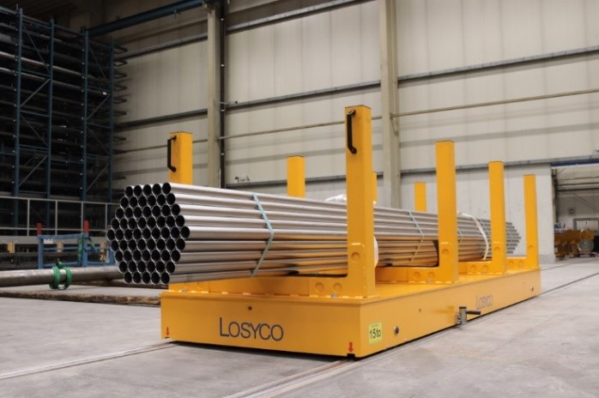
Caption: The floor-level LOXrail 40 system and customer-specific transport trolleys facilitate warehouse logistics

Image/s: | transport-rohrgebinde_2000.jpg | Characters: | 1028
File name: | 202407004_pm_loxrail_40_en | Date: | 07-03-2024
About Losyco
LOSYCO designs, builds, and installs intra-logistics systems for the manufacturing industry. The company based in Bielefeld, Germany, was founded by experienced engineers in 2016. LOSYCO’s core product is the LOXrail® floor rail system for easy transport and precise positioning of loads weighing several tons. LOXrail transport platforms can be operated manually or with auxiliary drives. LOSYCO also supplies handling equipment such as chain and roller conveyors, material management and storage systems, as well as sound-proof cabins and machine covers. LOSYCO supports customers wishing to transform their production processes to lean manufacturing and continuous flow production. LOSYCO is a member of the DRECKSHAGE Family.
Contact:  LOSYCO GmbH  Tim Schneider  Walter-Werning-Str. 7  33699 Bielefeld  Germany  Tel.: +49 . 521 . 945 643-0  Email: info@losyco.com  Internet: www.losyco.com |  | gii die Presse-Agentur GmbH  Christburger Str. 41  10405 Berlin  Germany  Tel.: +49 . 30 . 538 965-0  Email: info@gii.de  Internet: www.gii.de

