Press Release

Ship motors with RINA approval

Menzel Elektromotoren has manufactured two electric motors for marine applications for an Italian shipbuilder, complete with approval by RINA, the Italian naval registration company. The squirrel-cage motors will power the bow thrusters on a new seagoing coast guard vessel and a logistic support ship for the petroleum industry. Menzel’s modular approach enables flexible, application-specific motor designs and feature options. The motor for the new ship was implemented with IC 81W cooling, with a seawater-resistant air-to-water heat exchanger that can be supplied with seawater up to 32 °C. The second machine replaces an existing motor and was designed with cooling type IC 71W to match the available space. Here, water jacket cooling enables a more compact, lighter and quieter design of the entire drive system. The two VFD-driven vertical motors feature respective frame sizes of 450 and 500 and deliver outputs of 850 kW and 1000 kW at a nominal voltage of 690 V. The ship motors boast IP55 ingress protection. Menzel also offers motors with higher IP ratings for marine and petrochemical applications. The German family-run company supplies ship chandlers and the offshore industry with larger electric motors (from about 500 kW) for thrusters, pumps, fans and with special motors and explosion-proof versions according to current standards and energy efficiency classifications.
More about low, medium or high voltage squirrel-cage motors: https://www.menzel-motors.com/squirrel-cage-motor/

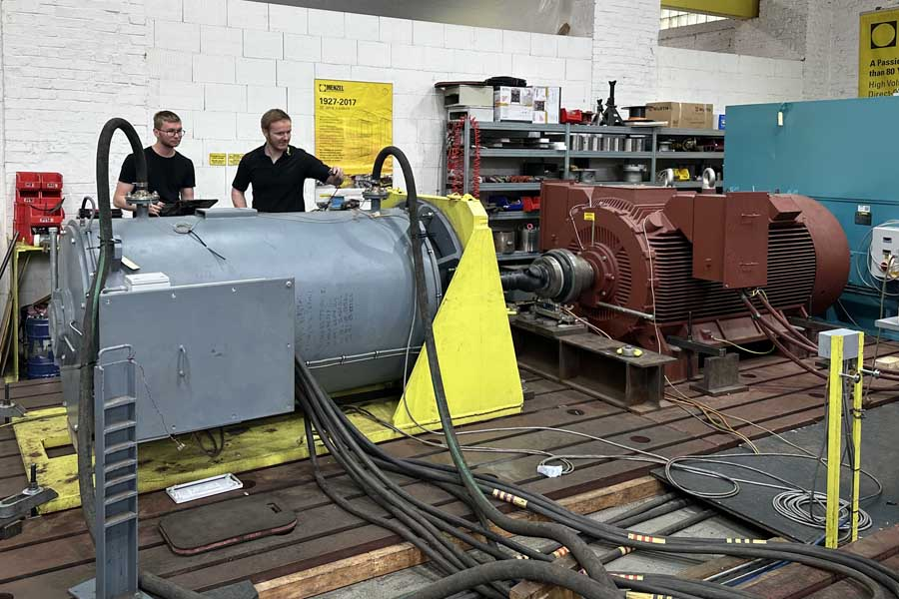
Caption: Menzel thoroughly tested the ship motors in its inhouse test field (here: squirrel-cage motor with water jacket cooling)

Image/s: | ship_motor_rina_ic_71w | Characters: | 1390
File name: | 202407009_pm_ship_motors_rina_en | Date: | 07-03-2024
About Menzel Elektromotoren
Menzel Elektromotoren GmbH has been manufacturing and distributing electric motors since 1927. The German family-run company based in Hennigsdorf near Berlin specializes in the delivery of large electric motors, including special models, within the shortest time possible. The product range comprises high and low voltage motors, DC motors, transformers, and frequency inverters. Services include motor production up to and beyond 25 MW and short-term adaptation of stock motors to application-specific requirements. In order to ensure short delivery times, Menzel maintains a large inventory with over 20,000 motors up to 15 MW. Qualified engineering, experienced staff, and state-of-the-art production and testing facilities help the manufacturer provide excellent reliability. Menzel operates subsidiaries in the UK, France, Italy, Spain, and Sweden, and cooperates with numerous partners worldwide.
Contact:  Menzel Elektromotoren GmbH  Mathis Menzel  Am Alten Walzwerk 2  16761 Hennigsdorf  Germany  Phone: +49 30 349 922-0  Email: info@menzel-motors.com  Internet: www.menzel-motors.com |  | gii die Presse-Agentur GmbH  Christburger Str. 41  10405 Berlin  Germany  Phone: +49 30 538 965-0  Email: info@gii.de  Internet: www.gii.de

