Press Release

OCT: one cable for servo and motor connection

In view of growing data volumes in automation and drive technology, the trend is towards so-called One Cable Technology (OCT). SAB Bröckskes, one of the technology leaders in industrial Ethernet cabling, has developed several application-specific product series for hybrid and OCT cabling. The special cable manufacturer offers SL 875 C low-capacity hybrid motor cables as connection solutions for SICK HIPERFACE DSL and HEIDENHAIN HMC6. Adaptations to other standards are available on request. Cables specified for HIPERFACE are available in 10 standard versions with outer diameters from 9.8 mm to 24.4 mm. In addition, there are four specifications in the HEIDENHAIN standard with diameters ranging from 10.8 mm to 15.4 mm. Robust, hard-wearing cable sheaths ensure that the cables are sufficiently flexible and durable to withstand narrow bending angles over the long term, even with minimal core cross-sections down to AWG 30, corresponding to a core cross-section of 0.057 mm². To achieve the lowest possible capacity, SAB Bröckskes has replaced the conventional PVC insulation with low-capacity insulation materials made of PE or PP. Additional small shield capacities ensure low-loss transmission. For optimal EMI protection, SAB Bröckskes motor and servo cables feature double shielding made of shielding braid and an aluminum-laminated PE film. The double shielding ensures interference-free operation of frequency inverters. Symmetrical stranding with a split protective conductor reduces inductive couplings and improves EMC properties.

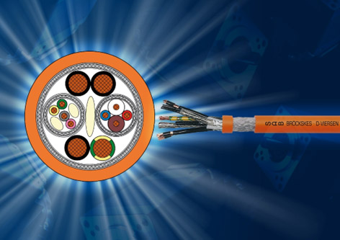
Caption: SAB Bröckskes low-capacity hybrid motor connection cable with integrated data transmission elements for encoder signals and feedback
Image: SAB Bröckskes

Image/s: | oct_SL875_2000.jpg | Characters: | 1548
File name: | 202407012_pm_oct_one_cable_en | Date: | 07-30-2024
Tags:
About SAB Bröckskes
Founded in Viersen, Germany, in 1947 by Peter Bröckskes as a one-man operation for electrical system design, SAB Bröckskes GmbH & Co. KG has grown into one of the world’s leading special cable manufacturers, now employing a staff of more than 550 who generate a turnover of over €134 million euros in over 100 countries. The portfolio includes cables and wires manufactured from a wide variety of materials as well as cable assembly and measurement solutions. All products are developed and manufactured exclusively at the Viersen headquarters. The company supplies various industries from industrial automation and communication technology to manufacturers of construction and agricultural machinery, railway and shipping technology and medical technology. SAB Bröckskes has a global presence with international subsidiaries and sales offices.
Contact:  SAB BRÖCKSKES GmbH & Co. KG  Sacir Adrovic  Grefrather Str. 204 – 212b  41749 Viersen  Germany  Phone: +49 2162 898-146  Email: s.adrovic@sab-cable.com  Internet: www.sab-cable.com |  | gii die Presse-Agentur GmbH  Christburger Str. 41  10405 Berlin  Germany  Phone: +49 30 538 965-0  Email: info@gii.de  Internet: www.gii.de

