Press Release

Special joystick from RAFI for Fendt tractors

For intuitive and simplified operation of loaders and various implements, Fendt contracted RAFI to develop a new generation of the loader joystick with unique features. Fendt specified that the new joystick should have a third valve, enabling simultaneous control of up to three loader functions, e.g. lifting the loader with bale gripper, retraction, and closing the bale gripper. Another requirement was that the joystick should enable comfortable control of tractor functions and complex ISOBUS-based implements such as potato harvesters, viticulture machines, and municipal machines. RAFI developed the fully configurable 3L joystick by expanding on its JOYSCAPE MULTI basic model. The 3L joystick integrates not only the standard loader joystick functions – control of the hydraulic valves or loader operation as well as control of the third and fourth hydraulic circuits – but also a thumb joystick to operate the third loader function. Functions can be freely assigned to up to 27 levels with the 3L joystick. Furthermore, the joystick features a freely configurable pushbutton which, with the standard reversing function, means the driver does not have to change hand position when using the loader. Function allocation is easily visible on the terminal. Users can also quickly and intuitively make changes using the terminal. To ensure extra safety, the joystick is secured against accidental operation. RAFI developed the splash and dust-proof joystick with IP5K4 degree of protection in compliance with ISO25119 Directives AgPL C. Thanks to a very low zero position play, the solution exceeds the normal industry standards.

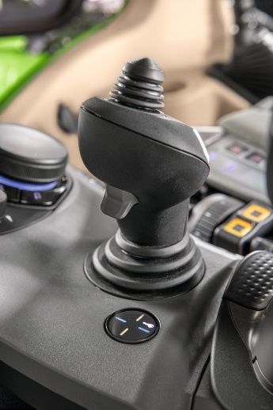
Caption 1: High-end solution based on the JOYSCAPE MULTI platform from RAFI: the newly developed, fully configurable 3L joystick with additional thumb joystick

Image source: AGCO/Fendt

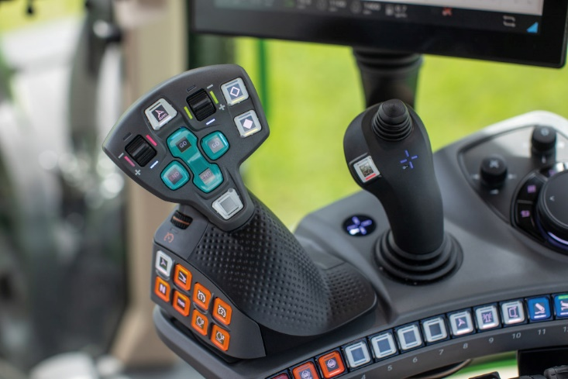
Caption 2: The 3L joystick (r.) enables simultaneous control of three loader functions plus extra functions freely assignable to up to 27 levels

Image source: AGCO/Fendt

Image/s: | 3l_solo_2000px.jpg  3l_in steuereinheit_2000px.jpg | Characters: | 1,703
File name: | 202407014_pm_fendt-joystick_en.docx | Date: | 07-16-2024
About the RAFI group
Founded in 1900, RAFI today develops and produces electromechanical components and systems for human-machine interaction. The range of products includes key switches, switches, touchscreens, control systems and electronic assemblies. RAFI products are employed in many industries including automation, medical technology, machine and plant engineering, road and railway vehicles, household appliances and telecommunication. The RAFI group operates internationally with more than 2,000 employees at sites in Germany, Europe, China, and the USA. Its headquarters are in Berg, Germany.
.

Contact:  RAFI GmbH & Co. KG  Tatjana Schweitzer  Ravensburger Str. 128–134  88276 Berg, Germany  Phone: +49 751 89-1468  Email: tatjana.schweitzer@rafi-group.com  Web: rafi-group.com |  | gii die Presse-Agentur GmbH  Christburger Str. 41  10405 Berlin, Germany  Phone: +49 30 53 89 65-0  Fax: +49 30 53 89 65-29  Email: info@gii.de  Web: www.gii.de

